Remote Assistance and Remote Desktop

‘Remote Desktop‘ and ‘Remote Assistance‘, are services that allow you to remotely control a PC from any where, let it be on your local network or even over the Internet. Although they appear very similar, there are some important differences between these two services. This facility appeared originally on windows XP and is available on all subsequent releases.

Remote Assistance uses Windows Terminal Services to share desktop and other resources between two PCs. Remote Assistance is designed for peer-to-peer use by Windows users. To have a successful Remote Assistance both users must have active Internet connections or be on the same local area network, and neither of them should be blocked by firewalls.

The Remote Desktop service allows you to take control of the remote computer without requesting for access. To do this you need to have administrator login details of the machine on which you will be doing Remote Desktop. Once logged in you will have complete control of the Remote computer. The difference to remote assistance is that you do not need the other user to be at their desktop.

A) Using Remote Assistance via e-mail (Windows XP)
You can request remote assistance by email or through Microsoft messenger. We will be using the email method. All machines in the office need to have outlook configured with a valid email account to use the SMTP service to send the remote request to the receiving user. If you cannot get to outlook, then you will also be able to send the email request through any online account as you will be creating the request as a file that can be attached to any email.

In the following Dialog, Computer A is the user requesting help, and computer B is the user giving the help.

Actions by Computer A (requesting Help)
. Open Help and Support Centre by clicking Start, and then clicking Help and Support.
. The Right hand pane of the resulting screen should have a section titled ‘ask for assistance’ and underneath this a link titled ‘Invite a friend to connect to your computer with remote assistance’.
Some manufacturers, Dell for example, often override the help system and the above section is not seen. In this case type remote assistance in the search box. Then click on the topic ‘Remote assistance’.
. The Remote Assistance page is displayed. Click ‘Invite someone to help you’.
. There are three available options for sending the Remote Assistance invitation: Windows Messenger, email, or saving the invitation as a file.
. Click on the link Save Invitation as a file (advanced).
. On the Save invitation screen, enter your name at the top field and leave the rest as they are and click continue button.
. On the next screen, leave the expiration interval at 1 hour, and enter a password. This will be used to access this session so you will need to phone the user who you are inviting to let them know what the password is. Click on the send invitation button.

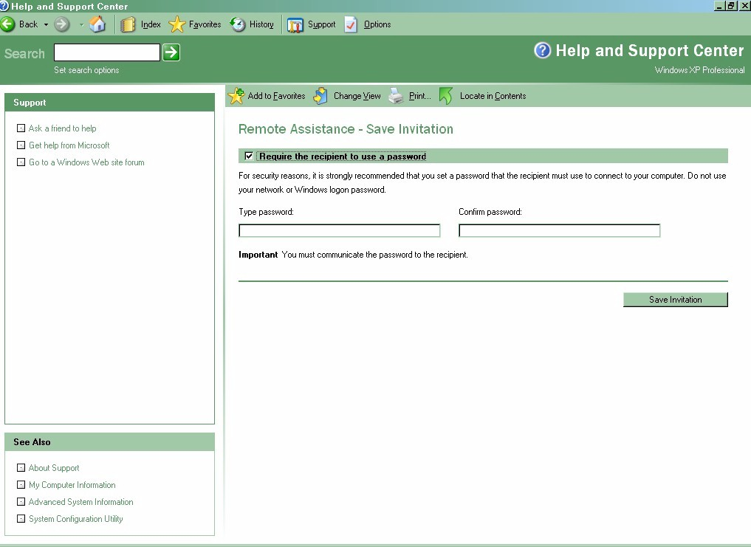

. Click on the button Save Invitation. You will be asked what name you want to save the file as and where to put it. I suggest you place the file on the desktop.
. Now logon to your mail (either outlook or internet email), and send an email to the person you are requesting help from, attaching the file you have just created.
. Your system is now waiting for the other user to use this file to request access. You can continue to use your machine as normal.

Actions by Computer B (Giving Help)
. The helper will receive an email request from Computer A with an attached file. Click on the attached file and a password dialog box is displayed. Enter the password that computer A gave you as the access password. On the screen prompt ‘do you want to connect now’, click on yes button.

Actions by Computer A (requesting Help)
. A remote Assistance display now appears on the screen informing you that computer B wants to start the session now, with a prompt to allow the session. Click yes and the session dialog screen is opened. This initial session is in read only mode, i.e. the helper on computer B at this stage can only see your computer, they cannot change anything.

Actions by Computer B (Giving Help)
. Once computer A has allowed the session, the Remote Assistance console opens on the Helper’s computer. At this point, the Helper can see everything on the computer A machine, in real time.
. Computer B can now request to take control of the Novices computer, by clicking the Take Control button on the Remote assistance console.

Actions by Computer A (requesting Help)
. The above action sends a message to Computer A notifying them that Computer B wants to share control of their computer. Clicking yes, will allow Computer B to use their own mouse and keyboard to enter things in real-time on computer A’s machine.

At any time Computer A can stop control of its machine by computer B by any of the following methods,
Press the ESC key.
Hold down the CTRL key, and then press the C key.
Click the Stop Control button next to the Novice's chat window.

B) Using Remote Assistance via e-mail (Windows 7/ Windows 10)
You can request remote assistance by email or through Microsoft messenger. We will be using the email method. All machines in the office need to have outlook configured with a valid email account to use the SMTP service to send the remote request to the receiving user. If you cannot get to outlook, then you will also be able to send the email request through any online account as you will be creating the request as a file that can be attached to any email.

In the following Dialog, Computer A is the user requesting help, and computer B is the user giving the help.

Actions by Computer A (requesting Help)
. Open Help and Support Centre by clicking Start, and then entering the search field ‘remote’. The following screen will appear

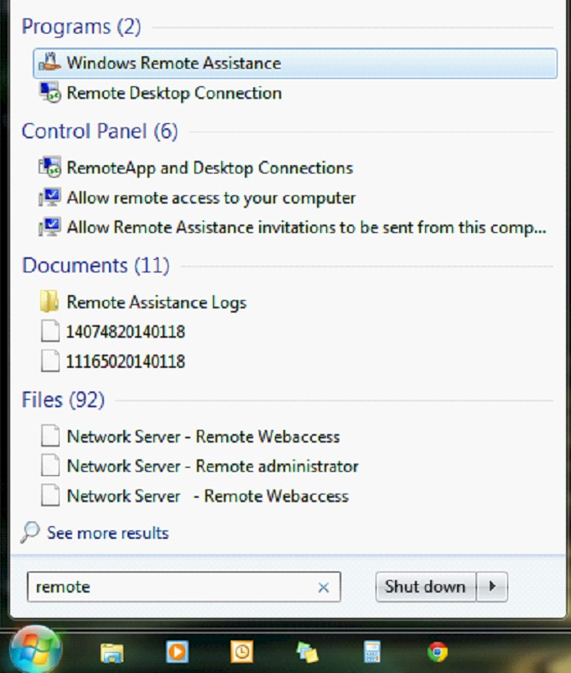

. Click on Windows remote assistance.
. The following screen will now appear

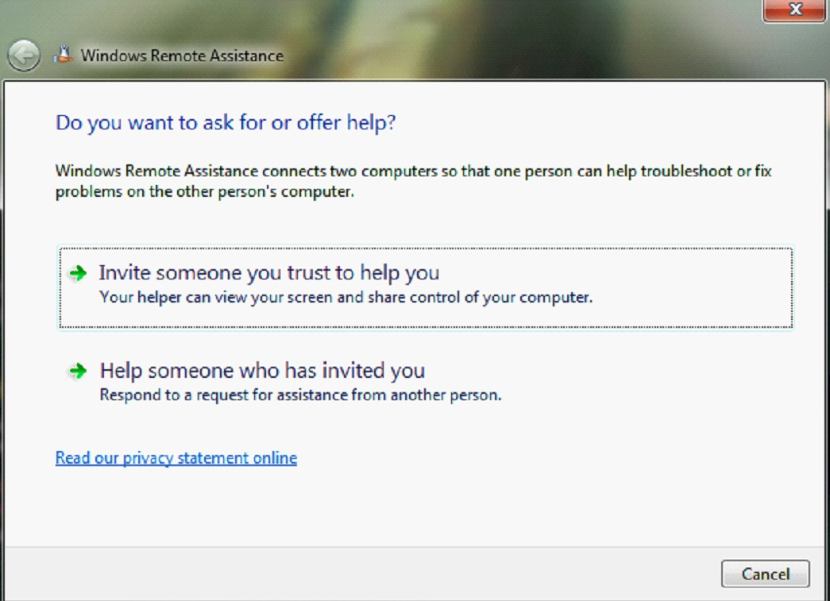

. The Remote Assistance page is displayed. Click ‘Invite someone you trust to help you’.
. A screen is displayed asking how you want to invite the person.
. Select the option ‘Save invitation as a file’
. You will be asked what name to save under (default – invitation) and where to save it. I recommend you save it on the desktop.
. The file is now saved and the following screen is displayed

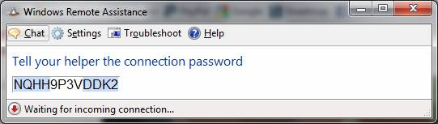

. Now logon to your email (either outlook or web mail) and attach the file created and send to the user you are asking for help. Inform them of the connection password displayed in the screen above.

Now wait

Actions by Computer B (Giving Help)
. The helper will receive an email request from Computer A with an attached file. Click on the attached file and a password dialog box is displayed. Enter the password that computer A gave you as the access password. On the screen prompt ‘do you want to connect now’, click on yes button.

Actions by Computer A (requesting Help)
. A remote Assistance display now appears on the screen informing you that computer B wants to start the session now, with a prompt to allow the session. Click yes and the session dialog screen is opened. This initial session is in read only mode, i.e. the helper on computer B at this stage can only see your computer, they cannot change anything.

Actions by Computer B (Giving Help)
. Once computer A has allowed the session, the Remote Assistance console opens on the Helper’s computer. At this point, the Helper can see everything on the computer A machine, in real time.
. Computer B can now request to take control of the Novices computer, by clicking the Take Control button on the Remote assistance console.

Actions by Computer A (requesting Help)
. The above action sends a message to Computer A notifying them that Computer B wants to share control of their computer. Clicking yes, will allow Computer B to use their own mouse and keyboard to enter things in real-time on computer A’s machine.

At any time Computer A can stop control of its machine by computer B by any of the following methods,
Press the ESC key.
Hold down the CTRL key, and then press the C key.
Click the Stop Control button next to the Novice's chat window.

c) Possible Problems when using remote assistance. (Windows XP)
a) Sometimes the initiating computer receives an error stating the request for assistance email cannot be sent because a program cannot be started. If the email ahs been setup correctly, this is because of one of two things, either the remote assistance feature has been disabled, or the dependant Terminal service is not active

i) To check remote assistance activation
. Right click on my computer icon on the desktop and click on the properties function on the drop down menu.
. Click on the remote tab and ensure that ‘allow remote invitations to be sent from this computer’ has been checked.

ii) To check the terminal services,
. Click on Start and run and enter command services.msc
. Under "SERVICES" find TERMINAL SERVICES, right click it, select properties and then choose STARTUP TYPE as AUTOMATIC. Save and the start button is highlighted. Now click start to activate the service. Should be ok now.

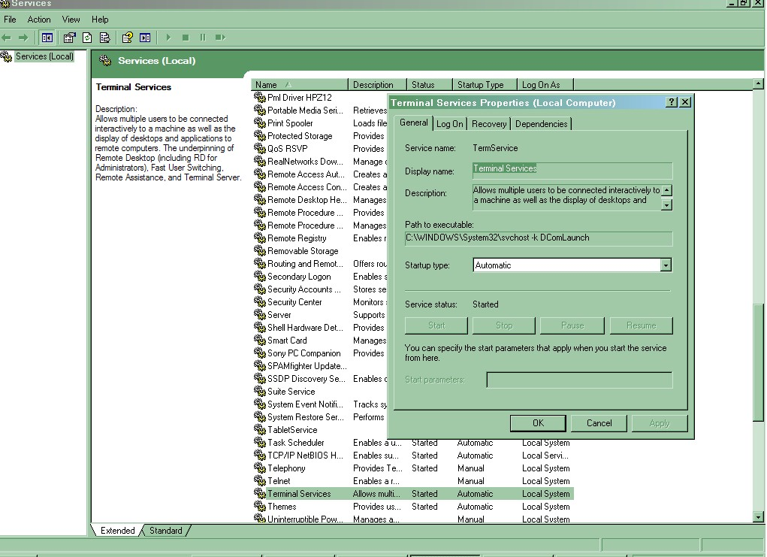

d) Possible Problems when using remote assistance. (Windows 7/Window 10)
a) Sometimes the initiating computer receives an error stating the request for assistance email cannot be sent because a program cannot be started. If the email ahs been setup correctly, this is because of one of two things, either the remote assistance feature has been disabled, or the dependant Terminal service is not active

i) To check remote assistance activation
. Right click on my computer icon on the desktop and click on the properties function on the drop down menu.
. On the resulting screen, in the left hand panel click on remote settings.
. Now Click on the remote tab and ensure that ‘allow remote invitations to be sent from this computer’ has been checked.

ii) To check the terminal services,
. Open Services control by clicking Start, and then entering in the search field ‘services’. On the resultant search the first entry will be the services application. Click on this and the following screen will appear.

