Network Attached Storage Setup at ECCP

NAS (Network Attached Storage) is a term used to describe a self-contained storage system which is designed to be attached to a traditional data network. It is primary function is to provide a centralised location for shared files, with security controlled by user definitions at a folder level. These folders can then be accessed, either as drives on a local network through a network share, or remotely through a browser.

The following Functionality was identified as a requirement for the new setup

. Ability to Support both the router and server remotely
. Ability to support the separate clients remotely
. Centralised automated backups
. Centralised file location
. Provision of disk redundancy in the event of a disk failure.
. Provide both project wide shared files and secure private files
. Files to be accessible both locally and remotely through the web.
. PC’s to act as shared workstation even though there is no domain logon.
. Mail to be centralised in some way without the overhead of an exchange server
. Low cost
. Low administration
. Gigabyte access speed
. Iphone/Ipad support

With Judicious thought and planning, all these function can be provided through NAS server although it does mean that there will be a set of ‘hard and fast’ rules that users must adhere to, especially in relation to how they use the mail client (outlook) and to user modifications to the local PC.
General rules and information
i) Anyone can now use any PC and get their own personal files and mail.

ii) The data on the server will be automatically backed up on a weekly basis at midnight on a Sunday to a USB drive. You can therefore request a copy of a previous file from the person designated to administer the backup. Files on the backup will only mirror the system as at the previous Sunday. It is not a cumulative backup. Therefore if you delete a file from the server, on the next backup it will be deleted from the backup as well.

iii) The Intention is that the server will be as seamless as possible. When you logon to user Admin, on any machine, you will run a program called connect (This will be in the list of programs and on the desktop). This will ask you for a username and password, and will attach 2 or more drives to you. The F drive will be your personal drive; no one else will see what you place on this drive. The G drive will be the Project wide drive. Anything you place on this drive will be seen by everyone in the project and can be updated by everyone (unless you put a password on it).
Depending on your role within the project you may then get one or more group drives connecting as H, I and so on. A group could be the ‘leadership’ group or the ‘training’ group. If you are a member of a group, for example ‘Training’ the H drive will be seen by all other member of that group, so you can share files that are relevant to the group only.
A list of the drives connected is given each time you run the connect program.

Drives are automatically disconnected when you logoff. If someone else wishes to use the machine you are on, then either logoff or run the disconnect program to release your drives. The other user will then run the connect again to get their drives.

iv) Your Logon name and password will be sent to your personal emails. The same name and password will be used or your email and email profile s please keep these secure.

v) At the switchover, your email will have been moved to the server, as will your favourites and certain other control folders.

Following the switch, please can you move all the files you wish to keep to the relevant drives and clear them from the C drive? I will not be moving the files myself, as this action will require a certain amount of clearing down for several reasons.

. Many of you may have a lot of personal files that are not relevant to the project. Since the sever is going to be backed up regularly we don’t want to fill up the server with personal music files or photographs. These should be kept on personal USB sticks rather than the local PC’s or server.

. Many PC’s contain duplicate files. Especially photographs and presentations relevant to the project. One copy of these should be placed on the shared drive and the remainder deleted. Please discuss carefully with other staff to see who has the latest copy of the file.

. We would like the server to hold all the projects files within 2 weeks so if you could ensure that you have completed the move of your files by this time it would be appreciated. During this period the backup job will run every evening to ensure that a complete backup is always up to date. After this period the backup will change to run weekly.

vi) Users have been given a Quota limit for file space on the server. This is different for different users. When you hit the quota limit you will not be able to place any more files on the server until you delete something. This is to prevent anyone from just copying all their files to the server. The amount specified should be adequate.

vii) When files are deleted on the server, they are not put into a recycle bin, rather they are placed in a folder on the relevant drive called ‘trashbox’. This allows you to recover a file you may have deleted by accident. For you personal F drives, please regularly clear this down, say once a week by deleting what’s in this folder. Do not delete the folder itself.

. I will handle the clear down of the trashbox in the group folders.

. Note that the all Trashboxes are excluded from the backups

viii)Do not place files or folders directly on the desktop. Files and folders should be created on the network drives, and then shortcuts placed on the desktop if you want to access them from here. For anyone who doesn’t know how to create a shortcut, Right click on the files or folder required and on the options given, select ‘send to, and from the locations displayed, select ‘desktop’ From now on you can access this folder as if it was on the desktop but anything you place in here will actually be placed on the network drive.

ix) Your favourites will have been directed to the special folder ‘Server Favourites (DO NOT REMOVE)’ on your F drive. This means that any machine you go to your favourites will automatically be picked up.

x) There are several folders on the F and G drives with the suffix ‘(DO NOT REMOVE)’. Please don’t. You will get in an awful mess if you do.

xi) There is an application program on each machine called Fastone Photo resizer. If you are going to merge some photos with the general work photo folder ‘Shared - ECCP Photos’ on the G drive, please reduce the size to a manageable size if you have used a large pixel size on your camera.

xii) All machines contain the same programs, applications and setup. Updates to programs may be out of sync with each other, but this is not a problem. However, please do not add any additional programs to any machines without talking to Mike. Thank you.

Common applications are held in the program group ‘!!!!! ECCP - Applications !!!!!’

xiii)In the event of a PC failure, you can now just move to any other PC and continue working. Additionally, the disks on the server are setup as a RAID array. This means that if a disk failure occurs on the server, because of automatic mirroring of the drives, the system will continue to run and we can replace the failed drive without any loss of data or processing time. New disks are rebuilt as part of the RAIDS mirrored pair, whilst the systems are operating.

Connecting your Drives
Whenever you logon to a machine at work, the first thing you must do is to connect your network drives. You will not have any mail, favourites, files or folders or anything until you have done this, so it should be the first action after logging on.

There are two ways of connecting your drives, either, click on the connect icon on the desktop, or click on ‘start > programs > !!!!! ECCP - Network !!!!! > Network server – connect network drives’.

. A DOS screen will open and inform you that you are connecting got the NAS sever.
. Press enter
. You will be asked for your username, Enter your name, e.g. Nancy, and press enter
. You will be asked for your server password. This has been sent to you in an email. Enter the password and press enter.
. Your drives are now connected and a status display will show you what drives you have.
. Press enter to close the DOS screen.

Screenshot of the connection Program
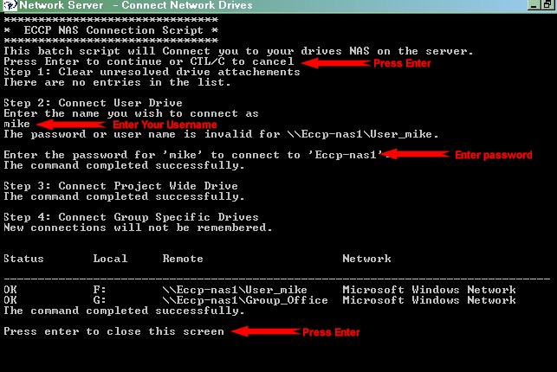

If you have any problem connecting, or a failure occurs, sat through entering an invalid password, then just ruin the disconnect program to remove any links in error and start again.

Screenshot of the disconnect Program
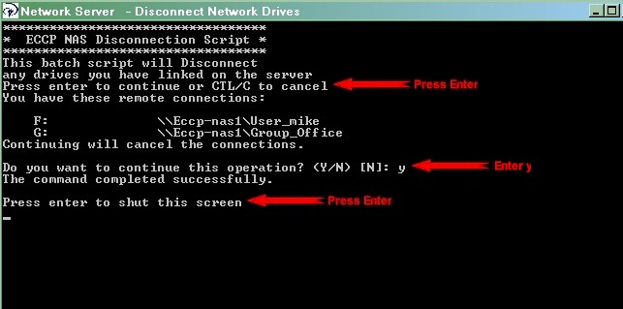

If you have any problem connecting, or a failure occurs, say through entering an invalid password, then just ruin the disconnect program to remove any links in error and start again.

By default, all attached drives will be disconnected when you logoff. If you are leaving your PC for a while and not logging off, and you wish to ensure your files and secured, just run the disconnect program to remove all links. You can then run the connect program again when you return to the pc. Similarly, if you are going to another pc that someone else has left logged on and it had their personal files and you need to access yours, then just run disconnect to remove their drives, followed by connect to enter your username and get your drives.

Mail
The biggest change that has occurred is in the use of outlook mail. To enable more than one user to have their own mail on a machine, outlook has now been changed to use Mail profiles. When you click on the outlook program to open your mail, the following prompt will be displayed asking you which profile you wish to logon to.
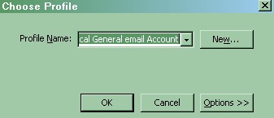

By default all machines have a default profile called ‘Local General Email account’. This account can be used when you haven’t got an actual email profile on this machine, and don’t want to create one. It could be used by clients, for example. One other use for this account is to allow remote assistance to be used, when you don’t have a profile, but want help from someone remotely, i.e. mike. It uses a system wide email account called email@eccp-ywam.org.uk.

If you are logging onto your own mail then click the down arrow and select your profile and then click the ok button.

WARNING - Do not attempt to open your personal mail if the F drive is not connected.

Outlook will now access your personal folders data file on your F drive. This is held in the directory ‘F:\Mail outlook (DO NOT REMOVE)’. For security, this will have your personal password on it, thus preventing anyone else from attaching your mail, in anyway to their outlook. It is a part if the data file itself; so if anyone gets a copy of the data file they still cannot access it without the password. The following screen is displayed -
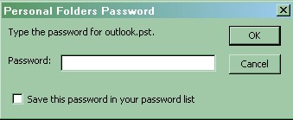

Enter your password. DO NOT save the password in your password list. Your outlook will now open as normal.

When the PC’s are initially setup, only the general users of a machine will have been setup with a profile on that machine. Thus, if a member of staff goes to a new machine and wishes to access mail from it, they will need to create their mail profile on that machine. This may appear to be complex but it’s actually quite easy to do and only has to be done once on each machine you intend to use.

Instructions for Setting up a profile
. Click on ‘start > programs > !!!!! ECCP - Network !!!!! > Mail – Mail Profile Setup’
. Click on the button ‘Show Profiles’
. Click on the ‘add’ button
. Enter your name as the name of the profile, e.g. ‘Felix’
. You will be sent to a screen for adding email accounts. Close this wizard for the moment. A warning screen is displayed, click ‘ok’.
. You will be returned to the profile screen.
. Highlight the Profile you have just created and click on the ‘properties button’
. On the setup screen displayed, click on the ‘Data Files’ button
. On the ‘Data Files’ Screen Click on the ‘add’ button
. Select as the file type ‘Office Outlook Personal Folders file’ and click on the ‘ok’ button
. Brose to your data file on the F drive, i.e. and click on this file to select it. A general properties screen is displayed. Click ‘ok’ to add it to your data files. Then click the ‘close’ button to return you to the Mail setup screen for this profile.
. Now click on the ‘email accounts’ button. On the email accounts wizard select ‘view or change existing accounts’. You haven’t actually got any but don’t worry about this. At the bottom of the screen is an entry ‘deliver new email to this location’. Change the location to the personal folders file you just added, i.e. the one on your F drive. Then click ‘finish’ > ‘close’ and ‘ok’ to shutdown the mail setup screens.

You now have your own profile, on a new pc, pointing to your existing data file on your personal network drive. You can have this profile defined on as many machines as you like, all pointing to the one data file.

You don’t however have your accounts installed as yet. To simplify this process there is a backup of each person’s accounts details on their F drive in the folder ‘F:\Mail Outlook (DO NOT REMOVE)\Outlook backup\BR-130507-00’. There is a utility program in the program group ‘!!!!! ECCP - Network !!!!!- called ‘Mail – Mail Backrex outlook accounts backup’ that will restore the settings in this file to your new profile. For security it will not restore your account passwords. You will need to add these in manually afterwards. To restore your settings just run this program, selecting as your input the backup file just described, and on the ‘accounts details to restore’ select your name.

Cloud Computing
i) Dropbox. There is an issue with trying to use Dropbox from a server. Basically it doesn’t like network drives. There is a workaround which will allow you to use this program, but it should only be used if absolutely necessary. Instead use Google drive which is fully supported if you need to use Cloud based sharing. The workaround uses the SUBSTR to access a local file as a network drive map letter, then removing that letter back to the network.
. Create a folder on local disk Eg: C:\Users\Heechung\Documents\Dropbox
. Create a Drive Letter Mapping eg:(F:) to the folder path in windows with following command
subst F: C:\Users\Heechung\Documents\Dropbox
. Install Dropbox desktop software in advanced Mode.
. Select the new local drive F: and sync either selective folders or all folder to local drive (which is original folder path). Wait till content is fully synced from web account
. Pause Syncing and Exit Dropbox
. Delete local folder drive mapping with following command
Subst F: /d
. Remap your network drives to pickup correct F drive
Connect
. Copy your content from original location to network drive
Eg; Copy created Dropbox folder from C:\Users\Heeching\Documents to F:\
. Start Dropbox. Now Dropbox should work as usual

ii) Skydrive. At the moment, the latest version of skydrive is unsupported in windows XP. This isn’t a restriction of the server, rather the operating system.

iii) Google Drive. Google Drive is fully supported on a network drive so the Google drive is the preferred method of cloud sharing of files. To ensure that the installation works across many users. When creating the local Google folder let the default name be used but place it at the root of the F drive.

Remote Assistance
All the PC’s in the office have been setup to allow remote support. Remote Assistance uses Windows XP/2003 Terminal Services to share desktop and other resources between two PCs. Using this facility, you can send an email to a remote user, i.e. mike, inviting them to share your terminal session. In this case, mike would receive your assistance request and logon through terminal services and ask for shared control of your PC. Upon acknowledging the request both computers have control. Both can type on the pc with their keyboards, and use their mouse to navigate the screen. The remote terminal in the office would appear as a window on the computer of the person assisting, in this case mike.

For detailed instructions on using remote assistance click on the following link http://www.eccp-ywam.org.uk/Earls_Court_Help/ECCP_Documents/Networking%20-%20Running%20Remote%20Assistance.doc

Server Files and Encryption
Both BoxCryptor and Truecrypt work on the server. There are a few anomalies to be aware of though.

To create a BoxCryptor file in a Google cloud folder, specify the full path of the Google folder on the F drive rather than leaving the system to default to just Google drive.

With Truecrypt creating a data file on a network drive will give you a false number of megabytes you can have. Just ignore this and put in whatever you want. Also, once you have mounted the drive for the first time, go into Favourites > Then add mounted volume to favourites. Then Organize favourite volumes and highlight the drive, then select mount selected volume when the host gets connected. In this way if Truecrypt is loaded, as soon as the F drive is attached, the encrypted drive will attach itself.

For a detailed explanation of all encryption for ECCP click on the following link
http://www.eccp-ywam.org.uk/Earls_Court_Help/ECCP_Documents/Encryption_and_Security/Security_and_Encryption_Policies.htm

Online Faxing
We intend to use an online fax service to send and receive faxes through emails. The Photostatting machine will be networked and used to scan any fax documents in. This function has not yet been setup or tested and instructions will follow separately when ready.

Remote Access
The Server comes with its own online access system, to allow users to access their files online through a browser. This access can be from anywhere, at home, an internet café etc. You do not need any special software installed as it uses native HTML, so any browser will suffice.

In this situation, you do not see the folders available as drives, as you would on an office PC but rather as folders.

The files and folders cannot be updated directly. However you can upload and download from your machine to your shared folders. You can therefore wither download a file, amend it then upload it again; or; from the browser you can open them in their native application, e.g., for a word document this would open in word, you can then edit the file and save to your local drive, then re-upload the file back to the server.

The only functions that you should not try, is to access the PST mail file remotely. Mail is only available through use of an imap definition on your local machine. Ask me if you want to set this up.

Using the remote access facility
From a browser go to the www.eccp-ywam.org.uk website, from the Links menu click on Information Systems and client support help, and from that menu select NAS web access. The following screen will appear

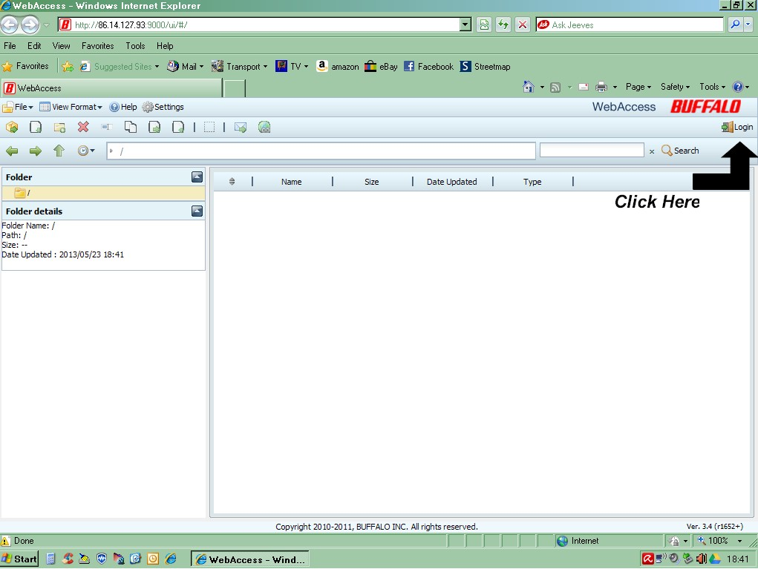

In the right hand section of the Web page is a logon field. Click on this and the sign on panel will appear in the centre of the screen as follows
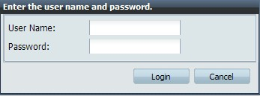

Enter your username and password. This is the same name as you use to logon at work in the connect program dialogue

The screen will now display the folders available to you. You can double click on any of them to open them.
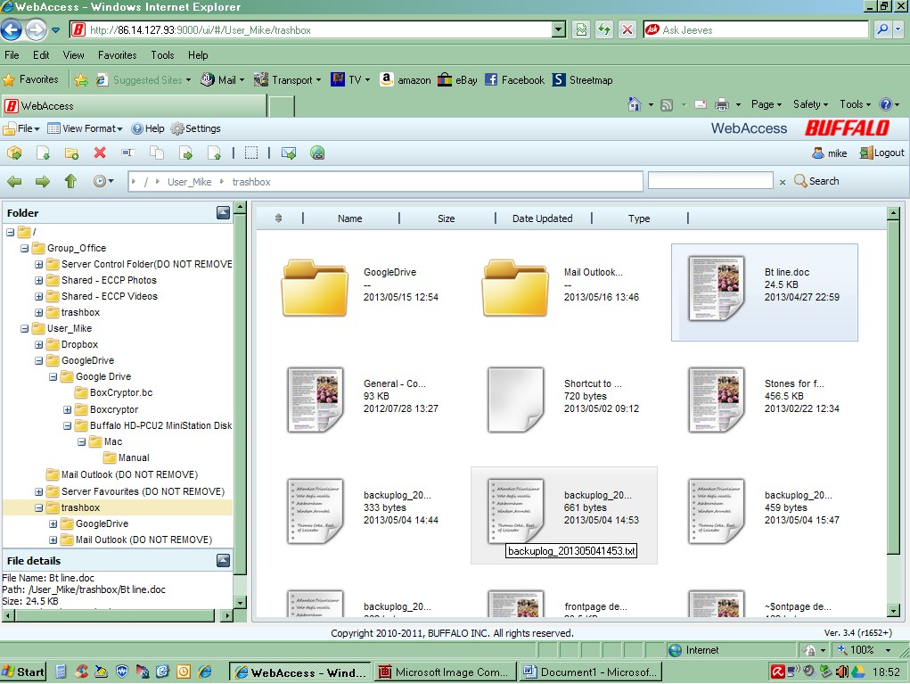

A file structure tree is shown on the left hand side of the screen. In the main panel, if you double click on any file, the system will attempt to open it within the browser using its associated application, i.e. word, pdf, a photographic application or music application. As mentioned above you cannot just update the file in situ, but you can update, save to local drive, and then copy the file backup again. There are icons on the screen to perform uploads, downloads, file deletes and many other functions.

When you have completed your task, just click on the logout button or close down your browser.

Using Personal Computers at Work
If you intend to take a personal computer to work, and you would like to use it in the same way as one of the office PC’s, all you have to do is copy the ‘c:/program files/ECCP Network Drives’ directory from any machine to your personal laptop. This directory contains the connect and disconnect programs. Link to the work network and run the connect program to pickup the relevant drives and the remainder of the applications and network tools used at work, including printer drivers and program groups, are all held on the G drive in a folder called ‘Server control folder (DO NOT REMOVE)’. You can install these as necessary.

This whole process of linking local drives uses the Microsoft net command structure. It does not work on apple machines. The only way an apple machine can access the server is through the NAS navigator logon function.

Using USB Drives at Work
When running the connect.bat you may get an error that it cannot connect a drive (either F,G or H) because a USB device you have attached has taken that drive letter. The problem occurs because the disk will try and use the first free available drive, which is often the ‘F’ Drive. (D and E being reserved for Primary and secondary CD/DVD Devices). To circumvent the problem just make sure you attach any USB devices after you have connected to the network.

However if you want to make a permanent connection for your USB drive, to an alternate permanent logical drive, and then to ensure it always connects as this, for example the ‘S’ drive, then do the following

01 Running the computer Management tool
Click > Run > enter as the command ‘%SystemRoot%\system32\compmgmt.msc /s’

02 Changing the Assignment
In storage section on left hand side click on ‘disk management’
Highlight in right hand side the USB drive you want to change. Right click with your mouse and on the dropdown menu select ‘change drive letter and paths’

Click on change button and in the assign the following letter box change the drive letter from its current logical drive path, e.g. F to S

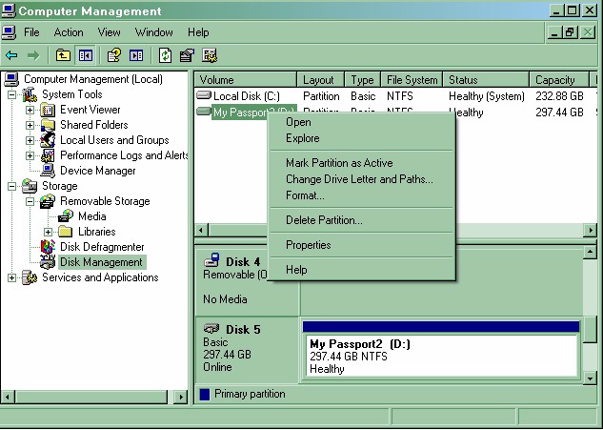

That’s it. Now every time you load this USB device it will be referenced as the S drive instead.

Use of Windows Logon Credentials
A user account feature of windows, called ‘windows logon credentials’ allows Windows to store logon information to network locations and websites, so that these credentials will be used each time you connect, thus saving you having to remember them for each site. Great in practice when you have a personal machine, or a machine where each user has their own logon, but not very helpful when users share the same logon as we do, i.e. Admin.
For this reason do not use this facility. If you are connecting to your drives and find that the system hasn’t asked for you password to authenticate you but just connected your drives, someone has set the logon credentials.

To delete them do the following

01 Running the computer Management tool
Click > Run > enter as the command ‘control keymgr.dll’

02 Highlight the relevant password stored and click on the delete button

Applications - Scanning Documents at Work
The Photostatting machine has now been connected to Felix's PC and shared on the network. All machines have a network connection to it and can print directly to the Photostatting machine provided it is switched on.

However, you can only scan from the Photostatting machine from Felix's PC. You can scan directly into any application that allows a TWAIN imaging driver, e.g. from within word or a picture program. To use this facility, open a word document, then click on Insert > Picture > from scanner or Camera. This will scan the document into the word document as a picture.

If this is for you own use, then place the saved file on your F drive on Felix's machine and you can get to it from anywhere else.

