NAS Buffalo Server Setup

We are using a Buffalo Link Station Pro duo (LS-WVL) as a server. This has two 1TB SATA drives that have been configured in a RAID-1 Configuration to provide hot swap capability in case of a failure. The machine has a fast access speed. A standard USB drive is 40mb/sec whereas LS-WVL on gigabyte Ethernet is 73Mb/sec

The system will be setup on the network with a gigabyte connection to the HUB/Switch. One machine in the office will also have Gigabyte connectivity to allow backup of the device.

Introduction and overview of the ECCP Client/Server design
A NAS server is primarily designed to provide a centralised location for shared files, with security functionality by user definitions at a folder level. These folders are accessed either as drives on a local network through a network share, or through browser online from a remote location. However we intend to utilise it in a much more complex manner.
In a normal client/server network a domain server is used to act as the centralised file location and much more. Using a domain controller running a network logon service such as Microsoft’s active directory, clients would logon to the domain from a PC rather than logging onto the operating system of the PC itself. In affect, the PC becomes a workstation of the network, rather than a personal computer, even when used remotely. Server based services, would provide centralised control of facilities. For example, mail would be provided by exchange server, Database control by SQL server and so on. User profiles are defined on the server, and do not have to be defined on the separate workstation/PC’s. At logon time, policies are applied automatically to the local registry on the workstation/PC to modify, amongst other things User configuration settings to apply user modifications to the environment, for example, the desktop. Obviously such a setup can be expensive and require a lot of administration to support the system.
In evaluating a system to provide for the current and future requirements for the project, the following Functionality was identified.

. Ability to Support both the router and server remotely
. Ability to support the separate clients remotely
. Centralised automated backups
. Centralised file location
. Provide both project wide shared files and secure private files
. Files to be accessible both locally and remotely through the web.
. PC’s to act as shared workstation even though there is no domain logon.
. Mail to be centralised in some way without the overhead of an exchange server
. Low cost
. Low administration
. Gigabyte access speed
. Iphone/Ipad support

With Judicious thought and planning, all these function can be provided through NAS server although it does mean that there will be a set of ‘hard and fast’ rules that users must adhere to, especially in relation to how they use the mail client (outlook) and to user modifications to the local PC.

Initial Server Configuration
This section describes how the server was originally setup.
a) Connect the server to an Ethernet port on the PC
b) Insert CD and install NAS Naigavitor2
c) Click on Navigator icon and the following screen is displayed. All configurations are done from here.
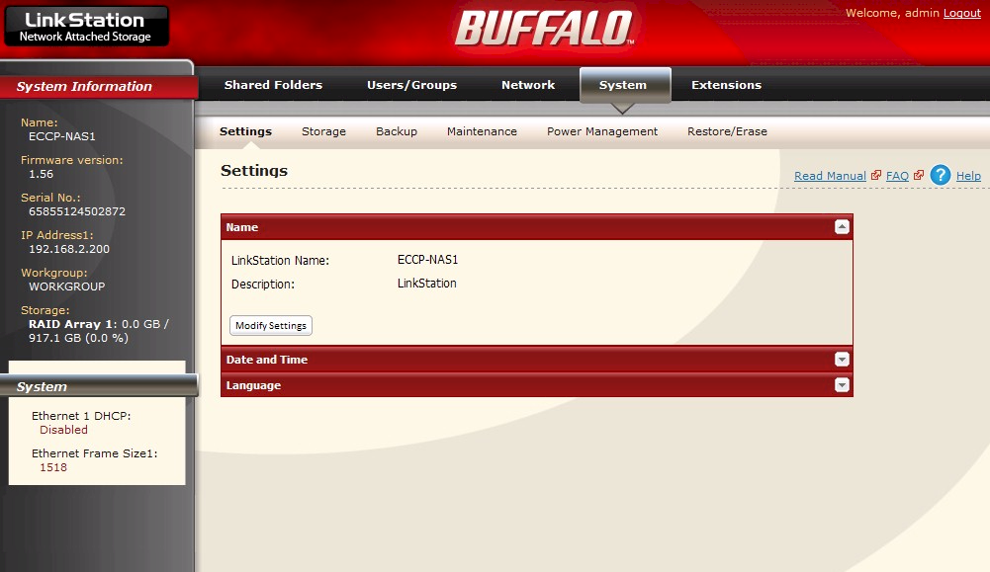

a) Setup System Parameters (Settings)
Click on ‘System’ Tab on the top Menu Bar
Click on the ‘Settings’ tab on the lower menu bar
Enter fields as follows
Linkstation Name – ECCP-NAS1
Description – Linkstation
Date/Time Source – Manual
Set the date and time and time zone
Display Language – English
In each section click ‘modify settings’, and then change to values above. Then click save. You may be logged out to allow setting to be set. This is normal, Just logon again.

b) Setup System Parameters (Storage)
There are two SATA 1TB drives in the NAS Server. Several RAID (redundant array on independent disk) modes are available. We will be using RAID 1 Mode. This is two drives working in a mirrored way. What is written to one drive is automatically written to the other. If one drive is damaged, the system continues running on the other drive. At a convenient time the NAS server can be switched off, the failed drive can be replaced, and the server switched back on again, and used as normal. Whilst the good drive is being used, the data is also being copied to the replaced drive. When this is completed, both drives will be back online and the server array in full disk mirroring mode again.

i) Create the Array
Click on ‘System’ Tab on the top Menu Bar
Click on the ‘Storage’ tab on the lower menu bar.
Click on the ‘RAID array’ section
All disks available will be displayed.

Select both hard drives, then click on the ‘create raid array’ button. This will take up to 5 hours for a 1TB array. The machine can be used whilst it is working. The light on the front will blink amber whilst it is being built. It will return to a solid light when it is finished

ii) Format the Array
Click on ‘System’ Tab on the top Menu Bar
Click on the ‘Storage’ tab on the lower menu bar.
Click on the ‘Disks’ section
Both the disks and the Array you have just created will be displayed.

Check the ‘Array1’ Radio button and click on the format disk button.
Enter as the Filesystems ‘XFS’
Click the ‘Format’ button

c) Setup System Parameters (Maintenance)
i) Setup email notification
The system can automatically email someone on a daily basis as to the current condition of the hardware in the server. It can also send an email when system settings are changed or an error occurs.
Click on ‘System’ Tab on the top Menu Bar
Click on the ‘Maintenance’ tab on the lower menu bar
In the email notification section, click on the 'modify setting' button.
Enter fields as follows
Notification - Check on the enable radio button
SMTP server Address - smtp.aaisp.net
SMTP Port number - 25
Authentication type - Login (SMTP-AUTH)
SSL/TLS - Disabled
Username - mike@eccp-wam.org.uk
Password - *******
Subject - Link station status report
Recipients - mike@eccp-ywam.org.uk, Click on the add button
Then check this recipient in the list of recipients
Report - Check all.
Click on the ‘save’ button

ii) Install Latest Firmware
Click on ‘System’ Tab on the top Menu Bar
Click on the ‘Maintenance’ tab on the lower menu bar
In the Firmware installation section, click on the ‘Check for update’ button. If the latest firmware is installed you will be informed. If there is a new firmware you will be given the option to update. Update if no-one else using the server.

d) Setup Network Parameters (Settings)
i) Setup IP Address Settings
Click on ‘Network’ Tab on the top Menu Bar
Click on the ‘Settings’ tab on the lower menu bar
In the IP address Settings section
Enter fields as follows
DHCP - Disabled (DHCP handled by BT Wireless switch)
Primary IP Address - 192.168.1.251
Subnet mask - 255.255.255.0
Default Gateway Address - 192.168.1.1
Primary DNS Server - 192.168.1.1
Secondary DNS Server -
Click on the ‘modify settings’ button

ii) Setup Network services
Click on ‘Network’ Tab on the top Menu Bar
Click on the ‘Settings’ tab on the lower menu bar
In the IP Network services section ‘Disable’ FTP
Click on ‘Save’ button

e) Setup Users and Groups
Each user will have their own username which will be used to define what folders they can have access to. Although users will also access group folders, this access control will be at user level, so no groups are required at this level apart from a default group pre-defined called ‘hdusers’. All users will automatically become a member of this group.

i) Change admin user
User Admin is predefined on the system. You will need to change the password for this user to prevent access.
Click on ‘Users/Groups’ Tab on the top Menu Bar
Click on the ‘Local Users’ tab on the lower menu bar
In the list of users, click on the admin user. This will display the current user details to the left of the screen.
Click on the ‘edit user’ button
Change the default password and click on the ‘save’ button.

ii) Setup ECCP Users
For each user at the project………………
Click on ‘Users/Groups’ Tab on the top Menu Bar
Click on the ‘Local Users’ tab on the lower menu bar
Click on the ‘create User’ button
Enter fields as follows
Username - <username> e.g. mike (all lowercase)
User id - Unique number. Starting from 1000
Description - Full username
Password - <Set by admin>
Confirm password - <Set by admin>
Primary group - hdusers
User quota - Check enable
Hard limit (GB) - xxmb: note - if a disk space quota set for user and group quota then smaller is used, Set according to each user to prevent overuse of the resource by personal music, photos and videos
Click the ‘save’ button

f) Setup Folders and security
Each user will have their own folder for personal use, and their will be additional folders for files that will be shared with other people within a group, for example counsellors or training. Finally there will be a business wide group called office that everyone will have access to so they can share files with everyone else in the office.
The size of the specific folder will not be controlled; however the total amount of space each user can create will be controlled by the implementation of User quotas, set when a user is setup.
When a user has logged on to a local PC, a batch program will be used to connect the relevant folders. The user folder will be connected as Drive F, The office folder as Drive G and any specific group folders as Drive H onwards. This leaves the upper alphabetic drive assignments to use used for encryption assignments.
Folder name syntax will be User_<username>, e.g. User_Mike, for user folders, Group_<Groupname>, e.g. Group_Leadership, for group folders and Groups_Office for the project wide folder. No other folder should exist on the system apart from the default ‘share’ folder, and any USB disks used for backups which will display as the name of the USB device connected.

i) Setup User Folders
For each user at the project………………
Click on ‘Shared Folders’ Tab on the top Menu Bar
Click on the ‘Folder Setup’ tab on the lower menu bar
Click on the create folder button
Enter fields as follows
Copy settings from - User_mike
Name - Folder name in correct syntax, e.g., User_Emmanuelle
Description - Descriptive text, e.g. user folder for Emmanuelle
Volume - Array1
Attributes - Read and write
Recycle bin - enable
Shared folder support - Check windows and apple only
In the user section, click on local user ‘mike’ and click the ‘remove’ button

Now click on the ‘add’ button in the ‘Local user’ section and add the user whose folder this is. And click the ‘add’ button at the bottom of the screen. This user is now added as a read user to the folder. Now do the same to add the user ‘backup’ to this folder. You should now have three users, admin, the ‘user’ themselves and ‘backup’. The admin user should have been created because you have copied the settings from user_mike in the first stage.

Highlight each user in turn and under the permission column, right click the mouse. Two options are given, ‘read only’ and read and write. By default the settings will be ‘read only’. Click on ‘read and write’ to give full access to this share.

Now click on the ‘save’ button at the bottom of the screen.

(Note that if you give a user and a group access to a share, and one is read and one read/write, if a user is a member of the group, then whatever Is the lower access will be used. We will not be using group definitions so this issue should not occur.)

ii) Setup Group Folders
Group folders are setup in a similar manner to the user folders except there are a lot more Users that you will add to have permissions in the final section.

g) Setup other server Services
The NAS server provides a range of server services which we will not be employing at the project. To use any of these functions they need to be enabled and configured in the network and system settings areas. These include

Web Server: The LinkStation can be used as a Web server. HTML, CGI scripts, images, and JavaScript are supported.

SQL Server: The LinkStation can be used as a MySQL server. A MySQL database may be installed and linked with the web server.

Network USB server: A Network-USB server lets you connect to USB devices attached to a LinkStation from multiple computers. Only one computer can be connected to each USB device at one time.
Before connecting a USB device to your LinkStation, first connect it directly to your computer so that the relevant driver is installed. While the Network-USB server is enabled, the following devices and functions will not be able to use the USB port, USB hard drives, print server, USB UPS connection and DirectCopy. A USB Hub can be connected to give more that one USB device. The Maximum number of connectable USB devices is 15 (not including one USB hub) and if any device is recognized as multiple USB devices, the maximum number of connectable devices is reduced.

Print Server: The LinkStation is equipped with a USB connector on the back And You can connect and share a USB printer to the LinkStation. The following rules apply however; The LinkStation does not support 2-way communication. For example, it cannot tell you the amount of ink left, Multi-function printers are not supported and Mac OS cannot print to a printer connected to the LinkStation.

Bit Torrent Client: BitTorrent is a protocol for sharing files. You can download files quickly since files are distributed on the network and network traffic is not concentrated, even with a large file. It does not keep anonymity, and it is easily known who publishes what files.

DLNA Server: The LinkStation is equipped with a DLNA (Digital Living Network Alliance) server. Videos, pictures and music saved on the LinkStation can be displayed or played on TV, audio devices, game devices and other DLNA compatible network devices.

ITunes Server: Computers on the network running iTunes can access MP3, M4A, and M4P music files from the LinkStation’s media server.

Squeezebox Server: The Squeezebox is a network music player by Logitech that can play back music stored on your network using your wired or wireless LAN. The Squeezebox device looks a bit it like a radio alarm clock. No PC is needed to play the music form the squeezebox server service.

Flickr Support: Flickr is a photo sharing website operated by Yahoo. After linking your LinkStation’s shared folder to Flickr, you can synchronize Your Flickr image data on your LinkStation shared folder. Images saved to the LinkStation’s shared folder can be viewed in Flickr, and images uploaded to Flickr can be viewed in the LinkStation’s shared folder. You can also View images from your Flickr account as a slideshow on your DLNA-compatible device.

Eye-Fi Connect: This allows you to transfer images from a digital camera with an Eye-Fi card to the LinkStation over the Internet.

Webaccess service: WebAccess lets you access files on your LinkStation through the Internet. Access restrictions can be set for folders that are shared; and automatic router settings by UPnP and redirect functionality from the buffalonas.com server (similar to Dynamic DNS) make configuration easy.

i) Setup Webaccess (Security)
The only additional service we will be using is the webaccess service to allow remote access to the server through the Internet. Security will be provided through the internal folder security and user passwords.

Click on ‘Extensions’ Tab on the top Menu Bar
Click on the ‘Webaccess’ tab on the lower menu bar
A list of folder shares is displayed. By default they are disabled. These are the remote access permissions for the relevant folder, when it is being accessed through Webaccess. Each share can be set as follows

‘Disable’ will prevent remote access to this share through WebAccess. This is the default setting.
‘Allow Anonymous’ will allow anyone to access the share. Don’t use this setting unless you want your LinkStation share to be available publicly to everyone in the world!
‘Allow All Groups/Users’ will allow only people who have an account on the LinkStation to access this share remotely.
‘Use Inherited Folder Permissions’ will allow people with an account on the LinkStation to access the share remotely only if they have read permissions on the specific share that they’re accessing

For each user and group folder; click on the folder name and on the resultant screen change the webaccess settings to ‘Use Inherited Folder Permissions’ and Click the ‘save’ button.

ii) Setup Webaccess (Service activation)
To switch on Webaccess server. Click on the down arrow in the webaccess service section at the bottom of the screen to display the settings then click on the ‘Advanced webaccess settings’ button to allow you to change the field.

Click on ‘Extensions’ Tab on the top Menu Bar
Click on the ‘Webaccess’ tab on the lower menu bar
Click on the ‘Advanced Webaccess settings’ button
Enter fields as follows
WebAccess Service: - Enabled
HTTPS/SSL Encryption: - Enabled
Use BuffaloNAS.com: - Enabled
BuffaloNAS.com Name: - eccp-nas1
BuffaloNAS.com Key: - <Set as default admin password for ECCP> DNS Hostname: -
Auto-Configure Firewall - disabled
External Port: - 9000
NAS Internal Port: - 9000
Exclusive session: - disabled
Session expiration time - 30
WebAccess URL: - http://buffalonas.com/eccp-nas1/
Click the ‘save’ button

iii) Setup Webaccess (Switch/Router Configuration)
By default Webaccess uses Port 9000 on the Buffalo server. This can be changed but why bother. So the ADSL router must now be configured to forward any requests received for the Web access service, direct to the internal server IP address, on Port 9000. Some routers term this ‘port forwarding’, and some, ‘creating virtual servers’. Setup Instructions are unique to each router. The following instructions are for the BT HUB.

Load your browser and enter http://192.168.1.254
Logon as Admin. The following screen is displayed
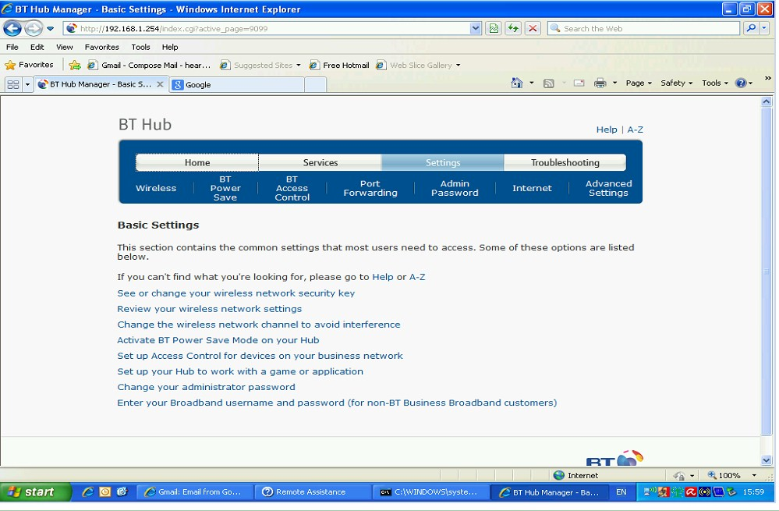

At the BT HUB screen, click on settings
On top Menu click on port forwarding
On Second menu click on Supported applications tab
Click on button add new game or application
Enter fields as follows
Game application name - Buffalo NAS
Copy an existing game/application - HTTPS
Protocol any, port range 9000 translate to 9000.
Click on add button
Delete the line for port 443
Click the apply button

On top Menu click on port forwarding again.
Enter fields as follows
Select game or application - Buffalo NAS
Select device - 192.168.1.251
Click on add button
Click on the apply button

iv) Setup Webaccess (Remote Access Device Setup)
There are now several ways in which a user can access the server
- By Accessing the website http://www.buffalonas.com/ Specifying the server name eccp-nas1 and clicking the connect button. The NAS service will then ratify the address of the router and connect you automatically.
- By linking direct to port 9000 on the external IP address of the router through your browser. I.e. enter http://86.134.172.136:9000 direct to your browser search. This will be the preferred method since it’s easier to change the external IP address The ECCP website will contain a link with the correct address already entered for you.
- By accessing the relevant instructions for your specific phone. For instructions to configure an iphone, windows phone or android to use webaccess, follow the instructions found at http://buffalonas.com/manual/en/

The ECCP website will be updated to allow access using method B specified above.

h) Setup Backup Functions
As well as performing a backup of your data using normal copy operations, from attached folder to attached USB disk; the System can also perform backups to a predefined shared folder on another Linkstation on a network, a shared ‘backup’ folder on the same disk or to a USB attached device.

Several backup modes are available, and the behaviour of each is as follows. The names in red are the names of the backup source and target source directories, where </share> is the sharename of the directory, for example, ‘User_Nancy’

Normal Backup - All files in the source folder, </share>, are backed up to the destination folder, /target/(date&time)</share>. Processing a Normal backup several times to a single target share, will create multiple copies of a backup on that target share, each in its own timestamp directory.

Overwrite Backup (Differential Backup) - All files in the source folder </share>, that don’t exist on the destination folder ‘/target/_backups</share>’, or where the file size or timestamp has changed, i.e. the file is new or has been changed, will be copied to the destination folder ‘/target/_backups</share>’. Any folders or files on the destination folder, that doesn’t exist in the source, i.e. those that have been deleted from the source, will also be deleted from the target, affectively creating a mirror image of the source.

Overwrite Backup (Complete/Differential Backup) – All files and folders in the source folder </share>, are backed up to the destination folder ‘/target/_backups</share>’. Any folders or files on the destination folder, that doesn’t exist in the source, i.e. those that have been deleted from the source, will also be deleted from the target, affectively creating a mirror image of the source. All files are overwritten every time a complete backup is performed. The difference between this backup and a normal backup is that there is only ever one backup on the target in the _backups directory on the target share.

Overwrite Backup (Append Backup) - All files in the source folder </share>, that don’t exist on the destination folder ‘/target/_backups</share>’, or where the file size or timestamp has changed, i.e. the file is new or has been changed, will be copied to the destination folder ‘/target/_backups</share>’. Any file that exists on the destination folder that doesn’t exits on the source will not be deleted. It will remain on the destination.

Overwrite Backup (Complete/Append Backup) - All files in the source folder </share>, are backed up to the destination folder ‘/target/_backups</share>’. Any file that exists on the destination folder that doesn’t exits on the source will not be deleted. It will remain on the destination.

Note that if a user is modifying a file regularly; because the backup copy is overwritten each time they will not be able to go back to the backup for an earlier version. There is only ever one copy held on the backup share.

Backup Job Schedule
We will be using a mixture of the differential and append backup to an external USB disk, plus a monthly copy from the external USB disk to a copy folder on the drive. The latter will allow you to recover accidentally deleted files for up to a year.

i) Format the USB Backup Disk
Click on ‘System’ Tab on the top Menu Bar
Click on the ‘Storage’ tab on the lower menu bar.
Click on the ‘Disks’ section
You will see the USB disk now connected

Check the USB Disk Radio button and click on the ‘format disk’ button.
Enter as the Filesystem ‘XFS’
Click the ‘Format’ button

ii) Setup Backup User
Click on ‘Users/Groups’ Tab on the top Menu Bar
Click on the ‘Local Users’ tab on the lower menu bar
Click on the ‘create User’ button
Enter fields as follows
Username - Backup
User id - Unique number. Starting from 1000
Description - User for full backup
Password - <Set by admin>
Confirm password - <Set by admin>
Primary group - hdusers
User quota - Leave Blank
Click the ‘save’ button

iii) Setup Shared folder on the USB disk for use as a weekly backup, and set permissions
Click on ‘Shared Folders’ Tab on the top Menu Bar
Click on the ‘Folder Setup’ tab on the lower menu bar
Click on the ‘create folder’ button
Enter fields as follows
Copy settings from -
Name - Usb_Backup_disk_1
Description - System Backup Drive
Volume - USB Disk 1
Attributes - Read and write
Recycle bin - Disable
Shared folder support - Check windows, apple and Disk Backup only
In the user section, click on ‘local users’ button, then click on the add button. Add users ‘admin’ and ‘backup’. And click the add button at the bottom of the screen. These users are now added as read only users. Highlight each user in turn and under the permission column, right click the mouse. Two options are given, ‘read only’ and read and write. By default the settings will be ‘read only’. For each user, Click on read and write to give full access to this share

Now click on the ‘save’ button at the bottom of the screen.

iv) Setup Webaccess to the Shared folder on the USB disk
This will allow the Backup and admin users access through webaccess to this folder for the backup backup drive.
Click on ‘Extensions’ Tab on the top Menu Bar
Click on the ‘Webaccess’ tab on the lower menu bar
Highlight the usbdisk1 folder name and on the resultant screen change the webaccess settings to ‘Use Inherited Folder Permissions’ and Click the ‘save’ button.

v) Create the Weekly backup job
Click on ‘System’ Tab on the top Menu Bar
Click on the ‘Backup’ tab on the lower menu bar.
Click on the ‘Create New Job’ button
In the job properties screen, Enter fields as follows
Job Name - Full_Weekly_Backup
Backup job schedule - Every Week
Backup Date - Sunday for 1.00 in morning
Backup Operation Mode - Overwrite Backup (Append Backup)
Backup Options - Check ‘Create target folder for backup’
Check ‘Exclude Trash Boxes from backup target’
Uncheck ‘Create Backup Log file’
Check ‘complete backup’

In backup folders section, click on the ‘add’ button and add all user and group folders one at a time. Specify as the source the original folder, e.g. User_mike, and the target as the volume created above in step1. This name will be in the format ECCP-NAS1@USBDISK1.

Click on the apply Button
Backup job task now added to the backup list

Note that if at any time you reformat the backup drive. Then the whole backup job definition must be re-created.

To stop a backup, just go into the definition and change the ‘job schedule’ to 'not scheduled'. This will not delete the definition but just stop it from running.

vi) Setup Shared folders on the main disk for monthly backup copies.
Click on ‘Shared Folders’ Tab on the top Menu Bar
Click on the ‘Folder Setup’ tab on the lower menu bar
Click on the ‘create folder’ button
Enter fields as follows
Copy settings from -
Name - Copy_Folder_<Month>
Description - Copy of the Backup for <month>
Volume - Array 1
Attributes - Read and write
Recycle bin - Disable
Shared folder support - Check windows, apple and Disk Backup only
In the user section, click on ‘local users’ button, then click on the add button. Add users ‘admin’ and ‘backup’. And click the add button at the bottom of the screen. These users are now added as read only users. Highlight each user in turn and under the permission column, right click the mouse. Two options are given, ‘read only’ and read and write. By default the settings will be ‘read only’. For each user, Click on read and write to give full access to this share

Now click on the ‘save’ button at the bottom of the screen.

Perform this step for all months, i.e. January to December so you have 12 backup copy folders.

vii) Setup Webaccess to the copy folders on the Shared monthly folders on the array.
Click on ‘Extensions’ Tab on the top Menu Bar
Click on the ‘Webaccess’ tab on the lower menu bar
Highlight the copy folders you created in the above step, one at a time and on the resultant screen change the webaccess settings to ‘Use Inherited Folder Permissions’ and Click the ‘save’ button.

viii) Create the Monthly backup copy job
Click on ‘System’ Tab on the top Menu Bar
Click on the ‘Backup’ tab on the lower menu bar.
Click on the ‘Create New Job’ button
In the job properties screen, Enter fields as follows
Job Name - Monthly_Backup_Copy_of_Backup
Backup job schedule - Immediate
Backup Date -
Backup Operation Mode - Overwrite Backup (Differential Backup)
Backup Options - Check ‘Create target folder for backup’
Check ‘Exclude Trash Boxes from backup target’
Check ‘Create Backup Log file’
Check ‘Complete Backup’

In backup folders section, click on the ‘add’ button and add as the backup source usbdisk1/_backups, and the target as the current month backup folder you created above, e.g. If it’s august then as the target ECCP-NAS1@Copy_Folder_August.

Click on the apply Button

Backup job task now added to the backup list, and it will run now to perform the current month’s backup. This job will then be amended each month to change the folder to a different month.

ix) Running the Weekly backup job
The weekly backup system, which is automatic, will contain a cumulative copy of all files, including those deleted, for the current month from the user and group directories. This will allow the whole disk to be restored as of the last backup, excluding the monthly copy directories, i.e. you will lose the ability to recover an accidentally deleted file if it is required to restore the whole system because of a total disk failure). However, during the month you will also be able to recover from the weekly backup, any file a user may have deleted within that month.

If you have changed the ‘job schedule’ to ‘not scheduled’ in the weekly backup setup step above, just go into the backup job defined above and change it back to weekly. Then just insert the external disk and it will run automatically at the allotted time.

If you haven’t changed anything, then just attach the external disk when you go home on a Friday evening.

On arrival on a Monday morning, check the backup logs, there will be one in each directory, detach the disk and store in a safe place.

x) Running the Monthly backup copy job, and reset the weekly backup
For the monthly backups ………..

On the last day of the month the administrator will perform the following actions to complete the differential back for the month, and then copy the contents of the USB backup disk to a copy folder on the disk. This folder will contain all files on the disk, plus any deleted files during the month. He will then setup a new differential backup for the new month.
This is done manually as follows

1 The administrator will change the weekly backup to an immediate backup to take the final backup for the month.

- Click on ‘System’ Tab on the top Menu Bar
- Click on the ‘Backup’ tab on the lower menu bar.
- Double Click to open the ‘Full weekly Backup’ job
- Change the ‘Backup job schedule’ field to ‘immediate’
- At the bottom of the screen click the apply Button. The backup will now start.

2 The administrator then copy the accumulative contents of the backup disc to a copy file on disk.

  - Click on ‘System’ Tab on the top Menu Bar
  - Click on the ‘Backup’ tab on the lower menu bar.
  - Double Click to open the ‘Monthly Backup Copy of Backup’ job
  - In the backup folders section at the bottom of the screen click on the add button
  - For the new backup folder enter as the ‘Backup Source’ to ‘usbdisk1/_backups’ and the ‘Backup Target’ to ECCP1-NAS1 @Copy_ folder_<monthname> The monthname should be set to the month you are beginning, e.g. if you are running this on 31st April then the monthname should be may
  - Click apply to add the new backup job.
  - Highlight the backup copy for last month in the backup folders and click on the remove button to only leave this months copy in there.
  - Change the ‘Backup job schedule’ field to ‘immediate’
  - Click on the Apply button. The monthly backup copy will now run.

3 The administrator will then change the weekly backup to an Overwrite backup (Complete/Differential) and set to run ‘immediate’. This will backup the user files as they stand now, i.e. without any files that have been deleted during the previous month.

- Click on ‘System’ Tab on the top Menu Bar
- Click on the ‘Backup’ tab on the lower menu bar.
- Double Click to open the ‘Full weekly Backup’ job
- Change the ‘Backup Operation Mode’ field to ‘Overwrite backup (differential backup)’
- Change the ‘Backup job schedule’ field to ‘immediate’
- At the bottom of the screen click the apply Button. The backup will now start.

4 After the monthly, weekly backup copy above, the administrator will now need to reset the weekly backup to the automatic standard fields, by changing the weekly backup back to ‘Overwrite backup (append)’, and to reset the run time to every Sunday.

- Click on ‘System’ Tab on the top Menu Bar
- Click on the ‘Backup’ tab on the lower menu bar.
- Double Click to open the ‘Full weekly Backup’ job
- Change the ‘Backup Operation Mode’ field to ‘Overwrite backup (append backup)’
- Change the ‘Backup date’ to ‘Sunday’ and time to ‘00.15’
- At the bottom of the screen click the apply Button. The backup will now be scheduled to run every week on a Sunday again.

xi) Restoring files from a weekly backup
The weekly cumulative backup contains not only a copy of the files as they exists on disk at the moment, but also a list of all the files you may have deleted during the current month, thus allowing you to get to a file you may have deleted during the month. At the end of the month this will have been reset, so you will need to restore from a monthly copy if you need a file that has been deleted in a previous month to the current one.

To restore files from the weekly backup, all you have to do is connect to the USB backup share and manually copy back the relevant files.

Connect to root of eccp-nas1, i.e. click on NAS navigator or enter the command
"C:\Program Files\BUFFALO\NASNAVI\NasNavi.exe" /open ECCP-NAS1

Logon as Admin or Backup so you can have read and write to all shared folders
You will see all the shares including ‘usbdisk1’
Double click the USB disk to open and you will see a backup data folder.
Double click this folder and you will see the names of the shared backup folders
Double click to open the latest copy of any of them and you will see the files
These can be opened or copied as you wish

Note; the disk is in XFS format so connecting the drive to a windows machine will show the drive as unformatted. The only way you will be able to read the data is by loading the PC in a standalone Linux system.

If the backup disk is loaded in this format then all files will be seen and can be copied. Therefore any confidential data on the server should be encrypted. Then the encrypted file will also be backed up, still in encrypted format.

xii) Restoring files from a Monthly backup copy
The Monthly copy of the weekly cumulative backup will allow you to restore a file that may have been deleted in a previous month for up to a year.

To restore files from the weekly backup, all you have to do is connect to the root of the server or logon as admin or backup to get to the monthly copy folders. Then all you have to do is copy the relevant file from the copy folder to the originating folder.

Connect to root of eccp-nas1, i.e. click on NAS navigator or enter the command
"C:\Program Files\BUFFALO\NASNAVI\NasNavi.exe" /open ECCP-NAS1

Logon as Admin or Backup so you can have read and write to all shared folders
You will see all the shares including the Copy_Folder_<Month> folders
Double click to open the latest copy of any of them and you will see the files
These can be opened or copied as you wish

i) Setup Server Remote Administration
Administration of the server is performed by logging onto port 80, i.e. the HTTP port of the server. This is ok if you are on the same network as you just need to specify the internal IP address of the server. However if you are on a remote network you need to specify the WAN IP address of the router and then forward requests for port 80 to the internal server. However if you do this, then you cannot then remotely administer the router. As it also requires Port 80.
The way around this is to forward port 443 on the router to the internal address of the server, then logon to the router using HTTPS rather than HTTP. This will give a certificate warning, but if you ignore it you will pass onto the server internally and the administration screen logon will appear.

So the ADSL router must now be configured to forward any requests received for the secure HTTPS to the internal server IP address. The following instructions are for the BT HUB.

Load your browser and enter http://192.168.1.254
Logon as Admin. The following screen is displayed

At the BT HUB screen, click on settings
On the next screen click on the advanced settings option.
This will now change to basic settings and more options are available
On top Menu click on port forwarding
On Second menu click on Configuration tab

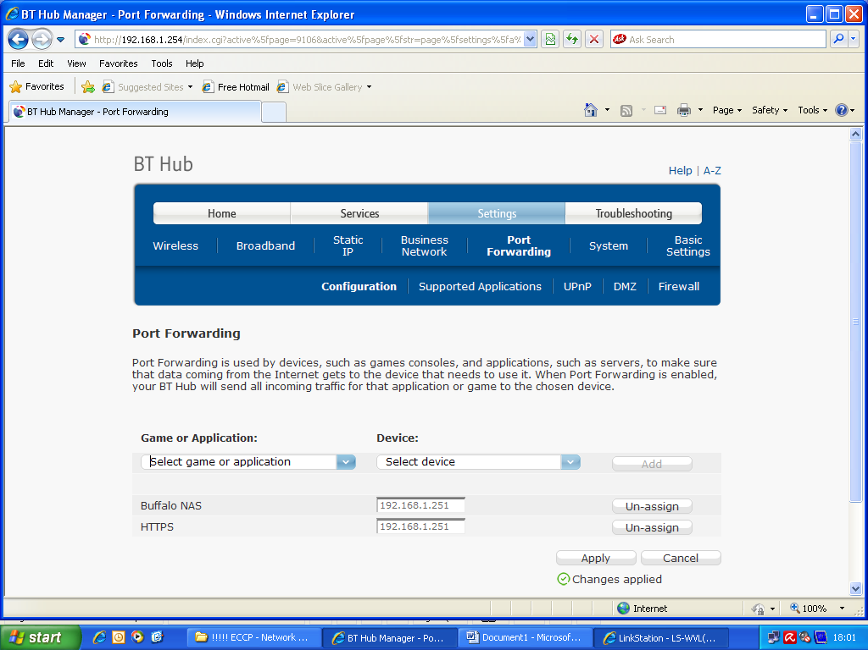

Click on down arrow in game or application and go down to select HTTPS
Change the device to user defined TCP/IP port
Enter as the port the address of the NAS device, i.e. 192.168.1.251
Click the add button
Click the assign button
Click the apply button

Configuration of Client PC’s
Using the NAS server, all data will in future be held on the server. As described in the introduction, by implementing a system whereby drives are connected from the server on a NAS logon_name basis, it also means that we can have a system whereby any user can use any machine whilst still having access to their own files. This does however require certain actions to be taken for the PC setup. Initially, the only user created on a PC will be user Admin so that all people only have to remember the one logon. A Client logon will be introduced at a later stage.

There is a new folder, ECCP_Network_Drives that will exist on each machine in the local C:\Program_files directory. As well as containing the help manuals and links for the server, it also contains two DOS batch programs, connect.bat and disconnect.bat. When a user logs on they will run the connect.bat program. This will ask them for their Logon_name and password. This is their own unique logon_name, e.g. mike; not admin. It will then connect the User folder for that logon_name, as the F drive, and the project shared drive as the G drive. It will then call another program, conngrp.bat that resides on the group drive to see if they have any additional drives to connect. The machine is now ready for use.

Documents, mail and favourites are all on the users F drive. They should no longer store any data on the C drive. It is very important that nothing gets stored on the desktop apart from shortcuts. If you want a folder to be accessed on the desktop, then store the folder on a network drive, either F, G, H etc, and place a shortcut to the folder on the desktop.

i) Install standard, connection and network Programs
. Connect to server as user Admin.
. Copy the folder ‘G\Server Control Folder(DO NOT REMOVE)\Standard Setup Programs\ECCP Network Drives’ to the local c:\Program Files Directory.
. Copy from the same directory the Start-up groups ECCP Network, ECCP Diagnostics and ECCP Applications to the global start-up group.
. Install all standard programs from the ‘G\Server Control Folder(DO NOT REMOVE)\ Standard Setup Programs(DO NOT REMOVE)\Program files – Diagnostics’ Directory.
Additionally copy all the folders in this directory, direct to the local ‘C:\Program Files’ Directory.
Delete any program groups they create.
. Enter Start > run > msconfig > startup and uncheck and startup options the above action may have created. When issued with a reload warning ‘exit without restart’
. Install all standard programs from the ‘G\Server Control Folder(DO NOT REMOVE)\ Standard Setup Programs(DO NOT REMOVE)\Program files – Applications’ Directory.
Delete any program groups they create.
. Enter Start > run > msconfig > start-up and uncheck and start-up options the above action may have created. When issued with a reload warning ‘exit without restart’
. Install NAS Navigator
Run ‘G\Server Control Folder(DO NOT REMOVE)\Navigator installation\LSNavi.exe’
. Install network printer
Run ‘G\Server Control Folder(DO NOT REMOVE)\Network Printers\clj4600pcl6.exe’
This will create a folder on the C drive called c:\HP CLJ4600. You can now add a local printer on a local TCP/IP port. The port number/address is 192.168.1.250 and when asked for the printer type and name, click on ‘have disk’ and direct it to this folder.
. Move favourites to the server.
Copy the directory ‘G\Server Control Folder(DO NOT REMOVE)\Server Favourites (DO NOT REMOVE)’ to the F drive.
Cut and paste the entries in folder ‘C:\Documents and settings\Admin\Favourites’ to the just created ‘F\Server Control Folder(DO NOT REMOVE)\Server Favourites (DO NOT REMOVE)’
Run Start > Programs > !!!! ECCP – Network !!!! > Admin – powertoys tweakui
Expand My computer section
Expand Special folders section
Select favourites as the folder and click on change location button
You will receive a warning, ignore this
Change the location to ‘F\Server Control Folder(DO NOT REMOVE)\Server Favourites (DO NOT REMOVE)’
. Create Local Shortcuts on the desktop
Create shortcuts on the desktop for the F drive calling it ‘Server - My documents’
Create shortcuts to the connect.bat and disconnect.bat programs on the desktop
Move any folders on the desktop to the local My documents folder ready to move to the server. Copy shortcuts back to the desktop.

ii) Activate remote access for the client
. Right click my computer > properties > remote > and check the radio button for ‘allow remote assistance’
. Click on start > run end enter command Services.msc
. Browse down to Terminal Services and double click to open
. Change the start-up type to automatic and click ok
. Double click on Terminal services again. Now you will find that the start button is no longer greyed out. Click on start to activate.

iii) Activate Mail profiles and move personal folders to server
. Access control > Mail > Show profiles, Create New profile ‘Local general email account’, Change startup to prompt for profile to be used
. Log onto outlook using profile ‘Local general email account’ and define account email@eccp-ywam.org.uk as pop account, this will create a PST on local drive. Note its name. This will always remain on the local drive.
. Access control > Mail > Data files. Check and note names of the archive and default PST files for profile ‘Microsoft outlook internet settings’. Manually copy all these filenames to the folder ‘F:\Mail outlook (DO NOT REMOVE)’ Folder.
. Access control > Mail > Show profiles, Create user profile <Username>
. Log onto outlook using profile ‘<Username>’. Do not define an account yet. This will still create a default outlook PST. Check this name in tools > options > Mail setup > Data Files
. Logoff outlook and go to folder C:\Documents and Settings\admin\Local Settings\Application Data\Microsoft\Outlook. And move the data PST file you noted had been created for <Username> to the desktop.
. Log onto outlook using profile ‘<Username>’ again. You will be told the system cannot find the PST file. Browse to the correct PST file on the F drive and click enter. The server file is now the default PST file. Do the same for the archive file if there is one for this user.
. Access control > Mail > Data files. And delete the profile ‘Microsoft outlook internet settings’. Aldo delete the PST files from the desktop.
. Log onto outlook using profile ‘<Username>’. In tools > options > Mail setup > Data Files > Settings > Change password. Set the user password for the data file.
. If you had to move an archive PST file as well, then redirect the archive location. In tools > options > other > Autoarchive > Move old items to, browse to F drive location to pickup the archive file there

iv) Move IMAP Accounts to the server.
You now have profiles running with two accounts, a default one on the local drive which allows any user to send mail and allows remote access to work. The second one is a private one for the user who is normally on this machine. When another user uses this machine you will need to create additional profiles. Now we need to move the IMAP accounts. This is more complex as IMAP automatically wants its files on the C drive and you cannot redirect on an outlook load, as you can for a Personal folders PST file.
. Delete any old IMAP PST files in the folder C:\Documents and Settings\admin\Local Settings\Application Data\Microsoft\Outlook.
. Log onto outlook using profile ‘<Username>’. Go to tools > email accounts >add a new email account, and add the IMAP account for the user. This will recreate the IMAP PST files for this user. Now logoff outlook. IMAP files have to be redirected from the control panel, not from within outlook or on a load.
. Access control > Mail > Show Profiles >Highlight the username > Properties > Data files, and. for the IMAP files, the file in the list and click the ‘open folder’ button and move them to the to the folder ‘F:\Mail outlook (DO NOT REMOVE)’.
. Access control > Mail > Show Profiles >Highlight the username > Properties > Data files, and, for the IMAP files, Highlight the file in the list and click the Settings Button. This time you will receive a failure and the system will ask where it is. Browse to the location on the network drive. The system will then change to pickup remote network IMAP PST files. This is the only way to get it to do this. If this is attempted by loading outlook and locating as you would do for the default PST file, then outlook just creates a new local IMAP PST file.

Server Administration
Once the Server has been initially defined, there is very little to do.

a) Configuration for new staff
i) Server Configuration
. Define the User on the server as specified in section ‘Initial Server Configuration - e_ii’ above
. Define a new user folder as defined in section ‘Initial Server Configuration - f_i’ above
. Update the backup job to add the new user folders you have just created, as defined in section ‘Initial Server Configuration - h_v’ above, E.g. Add folder User_mike.
. Add permissions as defined in section ‘Initial Server Configuration - f_ii’ above for any groups that the new user is eligible for. E.g. Group_office and/or Group_training.
. Add Webaccess inherited folder permissions for this user as defined in section ‘Initial Server Configuration - g_i’ above.
. Update the file ‘Server Control Folder(DO NOT REMOVE)\conngrp.bat’ in the ‘Group_Office’ shared folder on the server, to include any group links the new member of staff is eligible for. E.g. Training.
. Copy the standard set of control folders, ‘Mail Outlook Folder (DO NOT REMOVE)’ and ‘Server Favourites (DO NOT REMOVE)’ from the ‘Group_Office’ shared folder on the server to the ‘User_<username> personal folder on the sever where <username> is the name of the new member of staff.

ii) Mail Configuration
Logon to Andrews and Arnold website https://clueless.aaisp.net.uk/ mail administration and create new mailbox.
. At the logon screen, Logon as user mheccpc@a <for pw see mike/Samy>
. You will receive a 'Welcome to Andrews + Arnold Ltd administration pages' screen.
. This displays a graphical representation of system traffic, followed by a list of the domains we have control over. Only one domain should be displayed called eccp-ywam.org.uk. Under this entry to the right of the screen, are hyperlinks for DNS and Email Logs/setup.
. Select setup by moving the cursor over the words setup and left click with the mouse.
. This will display a list of the post boxes available currently at this domain.
. To create a new email, type the name in the username field and a password in the password box. Leave the remainder box free.
. Click on the add button.
. This email account in the form <username>@eccp-ywam.org.uk will be added to the list of available accounts at the bottom of the page.

Create PST storage file on the computer the user will be using by default
. Logon to the server by running connect.bat to pickup the F drive and G drive.
. Access control > Mail > Show profiles, Create user profile <Username>
. Log onto outlook using profile ‘<Username>’. Do not define an account yet. This will still create a default outlook PST. Check this name in tools > options > Mail setup > Data Files
. Logoff outlook and go to folder C:\Documents and Settings\admin\Local Settings\Application Data\Microsoft\Outlook. And move the data PST file you noted had been created for <Username> to the ‘F:\Mail outlook (DO NOT REMOVE)’ folder.
. Log onto outlook using profile ‘<Username>’ again. You will be told the system cannot find the PST file. Browse to the correct PST file on the F drive and click enter. The server file is now the default PST file.

Setup IMAP accounts for user.
. Log onto outlook using profile ‘<Username>’. Go to tools > email accounts >add a new email account, and add the IMAP account for the user. This will recreate the IMAP PST files for this user. Now logoff outlook. IMAP files have to be redirected from the control panel, not from within outlook or on a load.
. Access control > Mail > Data files, and, for the IMAP files, open the folder with the ‘open folder’ button and move them to the folder ‘F:\Mail outlook (DO NOT REMOVE)’ Folder.
. Access control > Mail > Data files, and, for the IMAP files, Highlight the file in the list and click the Settings Button. This time you will receive a failure and the system will ask where it is. Browse to the location on the network drive. The system will then change to pickup remote network IMAP PST files. This is the only way to get it to do this. If this is attempted by loading outlook and locating as you would do for the default PST file, then outlook just creates a new local IMAP PST file.

b) Backup Administration
The Backup is permanently set to run on a Sunday night at midnight, so should be completed by the time staff arrive on a Monday morning. So the last thing that should be performed on a Friday is to connect the backup disk to the server before going home and logon to backup to ensure you can see the disk ok.

First thing on Monday check the logs in each folder before disconnecting to ensure the backup completed ok. The disk should then be removed and stored off site for security.

On the last day of the month, setup and run the monthly backup copy and reset the weekly backup as defined in the section ‘Initial Server Configuration - h_x’ above.

Appendix A: Configuration Specifications

a) Router Details
Administrator User- Admin
Password now – (Standard Admin Password for project)
Wireless network name now YWAM KC
Wireless key now – ?????????? wpa/wpa2

Broadband IP Address – Dynamic
Internal LAN IP Address 192.168.1.1
Default Gateway – 217.32.146.172
Primary DNS – 194.74.65.68
Secondary DNS – 62.6.40.162

Printer address – 192.168.1.250

b) HUB Information
Genius 16 Port N-WAY switch Model GS4160

c) Server Details
Administrator User- Admin
Password - (see mike or Samy)
Name – ECCP-NAS1
Address – 192.168.1.251

