Creating a TrueCrypt Data Container

A data security container is a single data file, which will be used to hold encrypted files. It can reside on any drive that you have access to, e.g. your C drive, a USB drive or a network drive.

1) Start the TrueCrypt Program
The following screen will appear

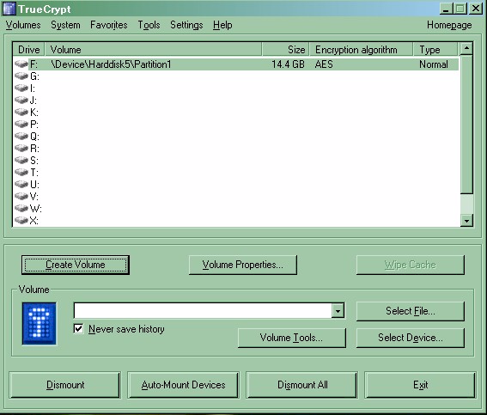

2) Click on the Create Volume Button
The following screen will appear

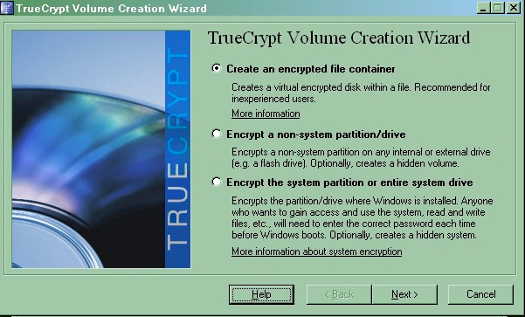

3) Click the ‘create an encrypted file container’ radio button
Click the next button
The following screen will appear
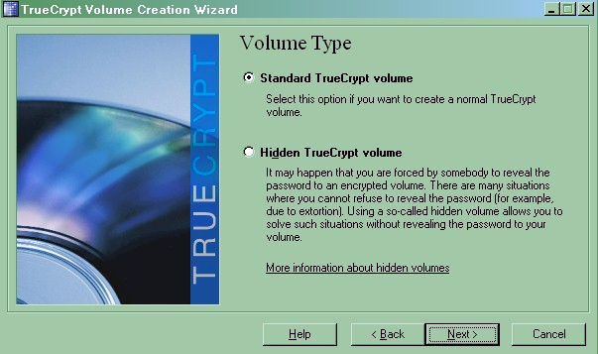

4) Click the ‘Standard TrueCrypt volume’ radio button
Click the next button
The following screen will appear

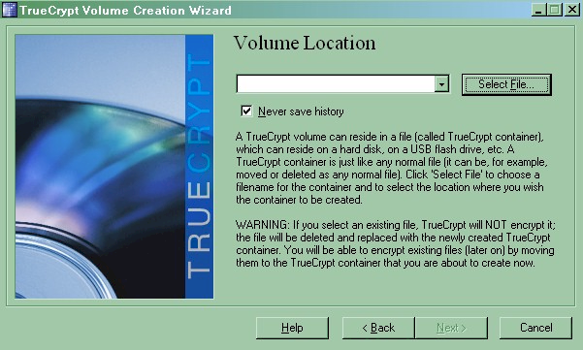

5) Click the ‘Select File’ button
A standard box displaying your files will be displayed asking you to select a path and filename.

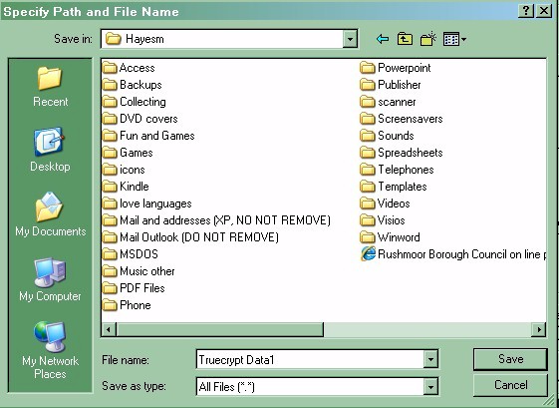

6) Browse to the directory you want to place the file container in and then in the filename field enter the name of the container you are going to create.

In the above I have browsed to the directory hayesm on the drive D and entered as a filename for the container TrueCrypt Data1

You can have as many TrueCrypt data containers as you wish and they can all be in the same physical directory or different physical directories.
Click the save button and the volume location screen is redisplayed with the relevant details filled in.

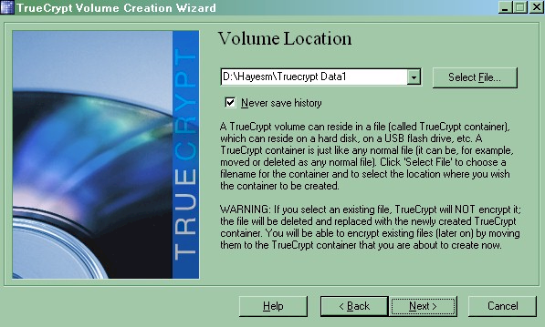

7) Click the next button
The following screen will appear

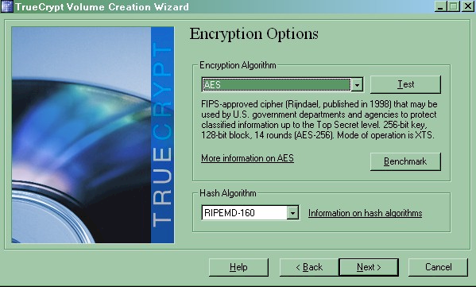

8) Leave all encryption options to default and click the next button
The following screen will appear

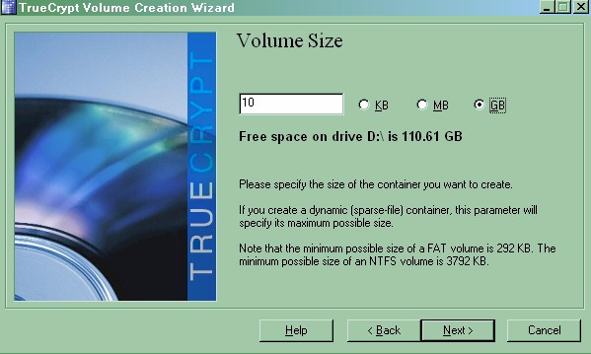

9) Enter the size of the Data Container you wish to create
Click the next button
The following screen will appear
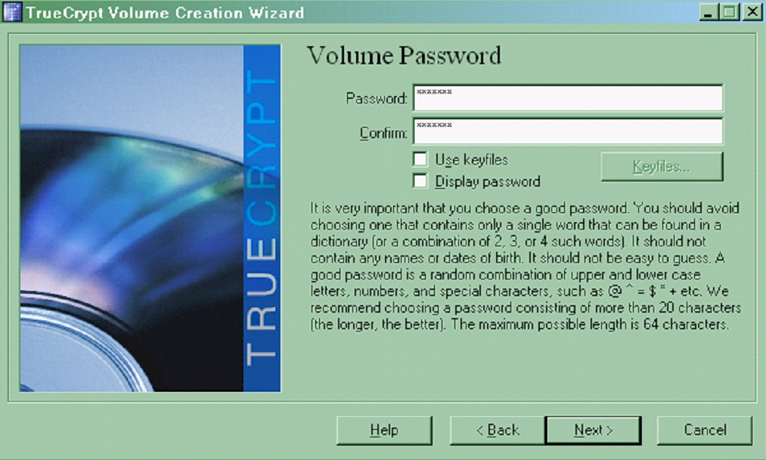

10) Enter the password you intend to use when this Data container is loaded. Note that the recommendation is for a password of more than 20 characters. You may think this an overkill, however I would recommend to use a phrase at least rather then a single word from a dictionary that can be broken with a ‘Brute force’ hacking program.
Click the next button
The following screen will appear.

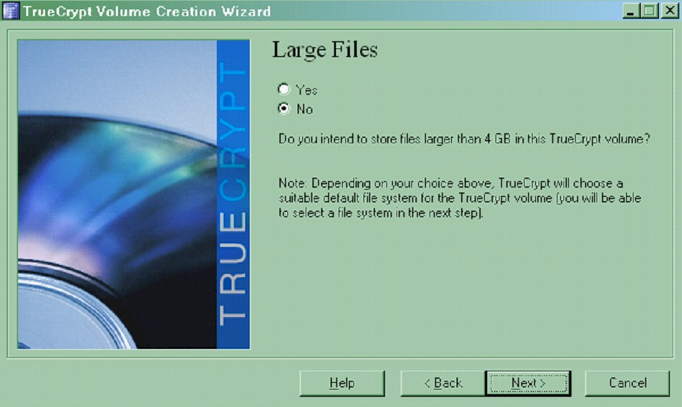

11) The only time you may want to store a file larger than 4GB is a database file or your mail PST file. I would therefore suggest you leave this at No and just click the next button.
The following screen will appear.

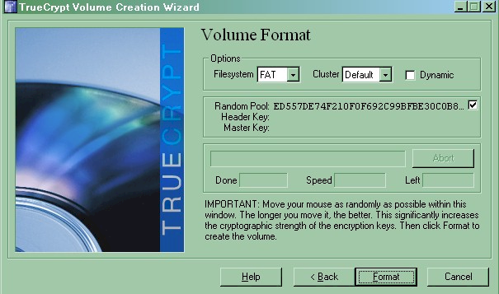

12) Move the mouse around within the box as much as you like. You will notice the random pool data changing all the time. As the details state the more you move the mouse the more complex the strength of the encryption so move the mouse for 20-30 seconds at least.
Then click on the format button. Formatting will now begin

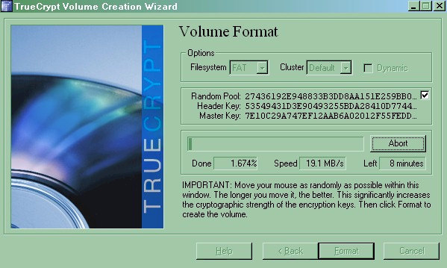

The screen is re-displayed showing the process of the format.
The data container will now be formatted
On completion a volume created screen is displayed
Click ok
Click Exit to exit the program.
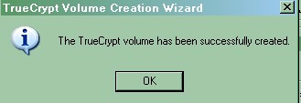

Mounting a TrueCrypt Data Container

To access the encrypted files, you need to mount the Data container through another drive letter. When you do this for the first time, you do have the option of informing the system to remember your request, so that every time you load your machine it will automatically load the encrypted Data Container Volume. It will not however remember the password. For security, you will be prompted each time you load your machine.

1) Start the TrueCrypt Program
The following screen will appear
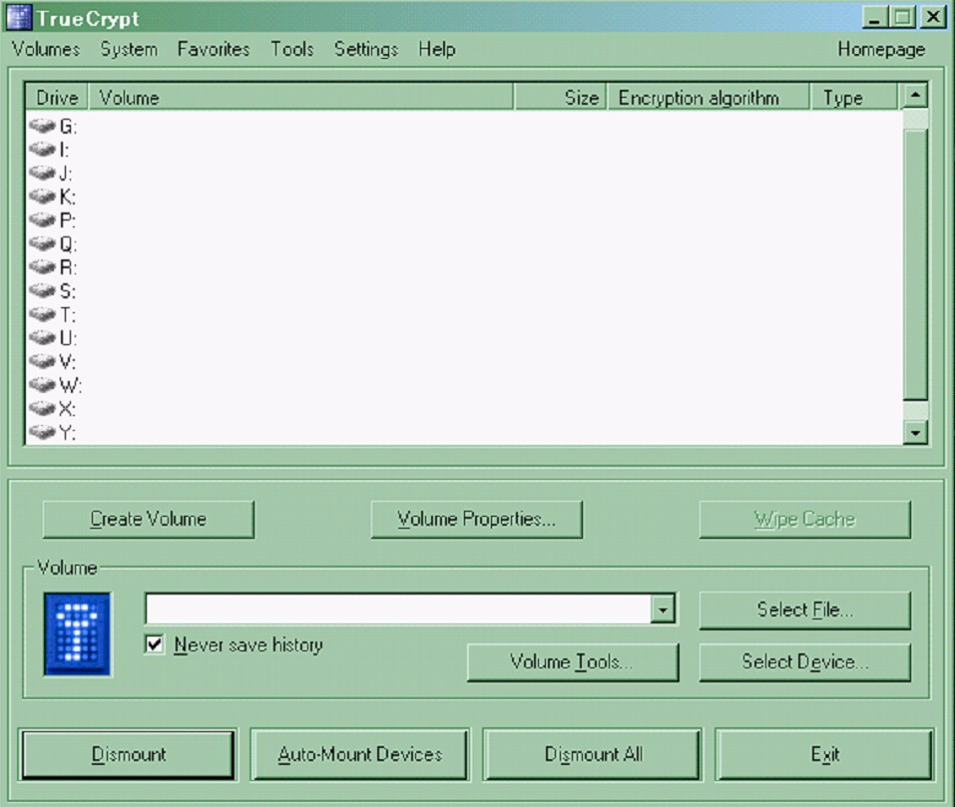

2) Click on the Select File button
A standard box displaying your files will be displayed asking you to select a path and filename.

3) Browse to the directory containing the file container and highlight the entry so it is placed in the Filename field.
Click the save button and the volume location screen is redisplayed with the relevant details filled in.

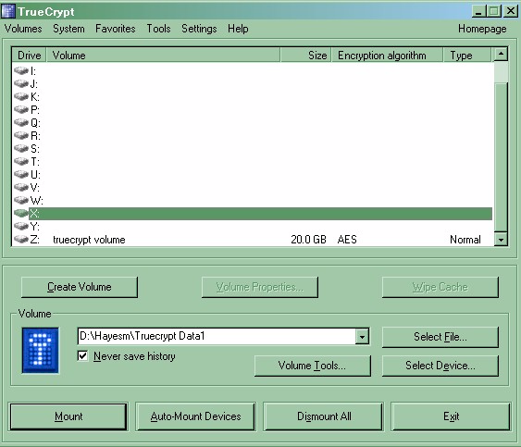

4) You will be returned to the main screen with the partition inserted into the volume field.
Click on the drive letter in the upper portion of the screen that you wish to use for this Data container, and then click the mount button.
The system will now display the load screen and ask you for the password as follows.

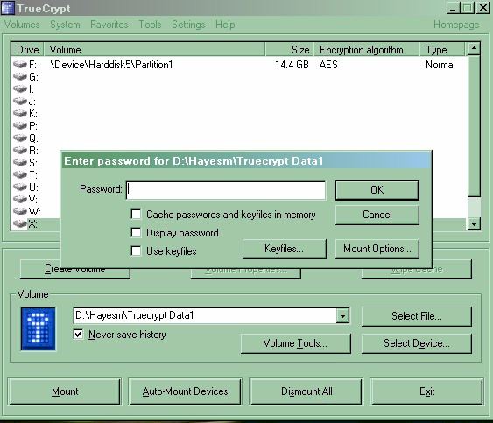

Enter the password
The TrueCrypt main screen will be redisplayed with the drive loaded as follows

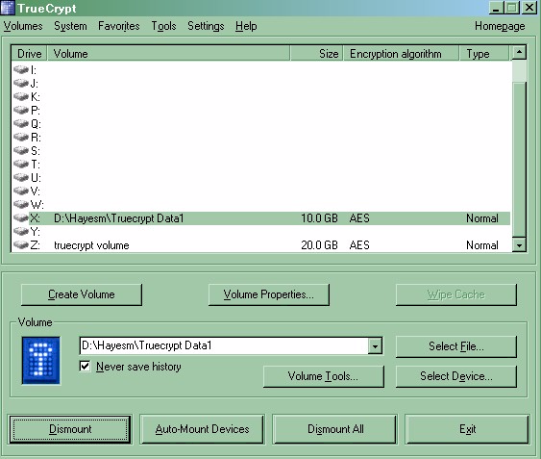

5) Highlight the loaded partition in the top panel of the screen, and click on the Favourites menu on the menu bar.
On the drop down menu select ‘add mounted volume to favourites’
The following screen will now be displayed

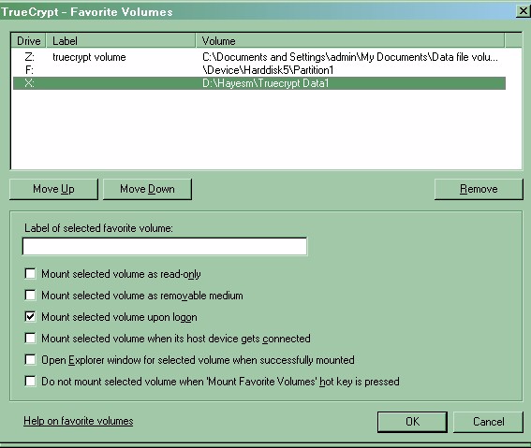

6) Highlight the mounted volume and check the ‘mount selected volume at Logon’ field.
Click ok to return you to main TrueCrypt menu.
Then click Exit.

Using a TrueCrypt Data Container

From now on each time you switch on your computer, you will be presented with the panel to enter the password as follows.

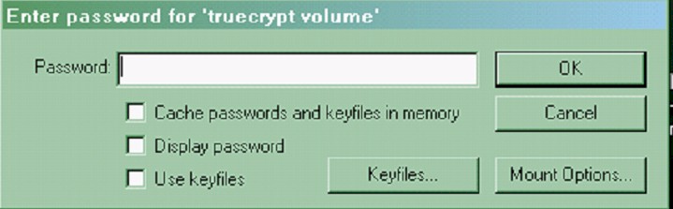

The encrypted Data container will then be loaded as a drive and can be used as any normal drive by copying files to this drive or edit/run files directly from the drive. E.g. if you have the container loaded as the X drive, access them directly from this drive. TrueCrypt performs On-the-fly encryption, meaning that data is automatically encrypted right as it is saved and decrypted right as it is loaded, without any user intervention.

Warning

TrueCrypt have not implemented any 'backdoor' (and have stated they will never implement any even if asked to do so by a government agency), because it would defeat the purpose of the software. TrueCrypt does not allow decryption of data without knowing the correct password or key. They cannot recover your data because they do not know and cannot determine the password you chose or the key you generated using TrueCrypt. The only way to recover your files is to try to "crack" the password or the key, but it could take thousands or millions of years (depending on the length and quality of the password or keyfiles, on the software/hardware performance, algorithms, and other factors). If you find this hard to believe, consider the fact that even the FBI was not able to decrypt a TrueCrypt volume after a year of trying.

Do not forget your passwords

