Encryption using BoxCryptor

BoxCyptor is an alternative method of encrypting data to Truecrypt. BoxCyptor will create a folder containing files encrypted by the program, and mount that folder as a drive. Unlike Truecrypt, you can see the folder and the files within it through a normal explorer window. You can also delete any files held there, and add any files direct to the folder. If you add in this manner they will not be encrypted however. Files stored in the folder through the BoxCryptor drive will be encrypted automatically so always copy to the drive letter, e.g. the Z drive.
There is also a file created used to hold the Key data called the keyfile (.encfs6.xml). This is needed by BoxCryptor. This file holds all information required for encrypting and decrypting your data. If the file gets lost or overwritten, you will lose access to your data! Sadly, because you can access the folder directly, this file can be deleted, Then its bye bye data.

BoxCryptor does however have several redeeming features. It has been specifically designed with the cloud and mobile computing in mind; and when asked for a location for the encrypted folder the program has, as possible options, Google drive, Dropbox and skydrive. There is also an app available to access the folder directly through an iphone or an android phone. Additionally, unlike Truecrypt, you don’t need to unload the drive letter from the folder to allow online synchronisation to occur, as the folder is seen as a normal folder and doesn’t require exclusive locks by the encryption software.

Finnally, although the software states that the free version will only allow one encrypted folder attached as a drive, it doesn’t mention the fact you can have as many encrypted folders as you like, all with different passwords, if you so require. The only real restriction is you can only have one loaded at a time. However it is a simple matter to unload one and load another through the BoxCryptor program.

1) Start the BoxCryptor program. This will load an icon to your quick start menu on the bottom right of your screen.
Right click on the BoxCryptor icon and select ‘Preferences’
The following screen will appear

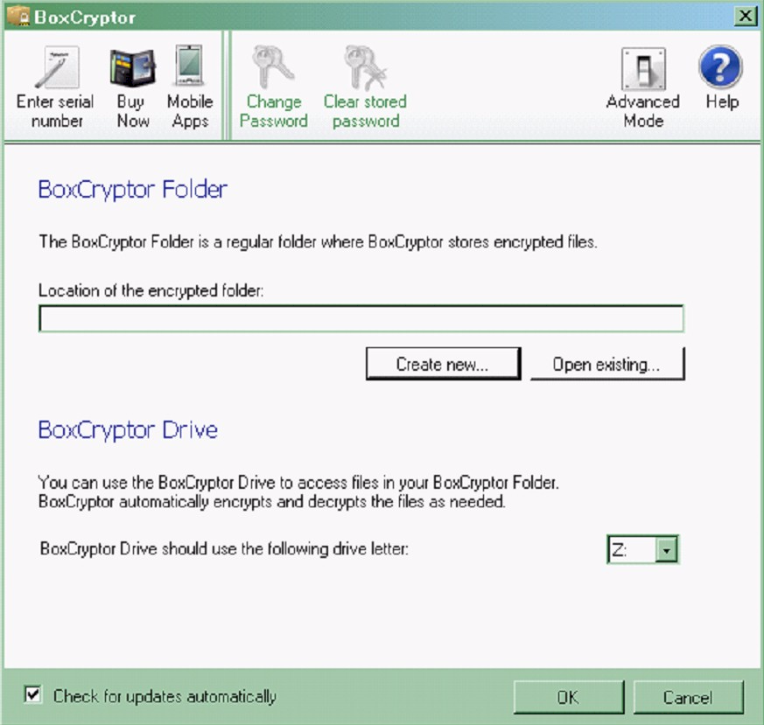

On this screen you can click the advanced mode to get more options. This would allow you to change various options such as the encryption method for this folder.

2) Click on create new
The following screen will appear
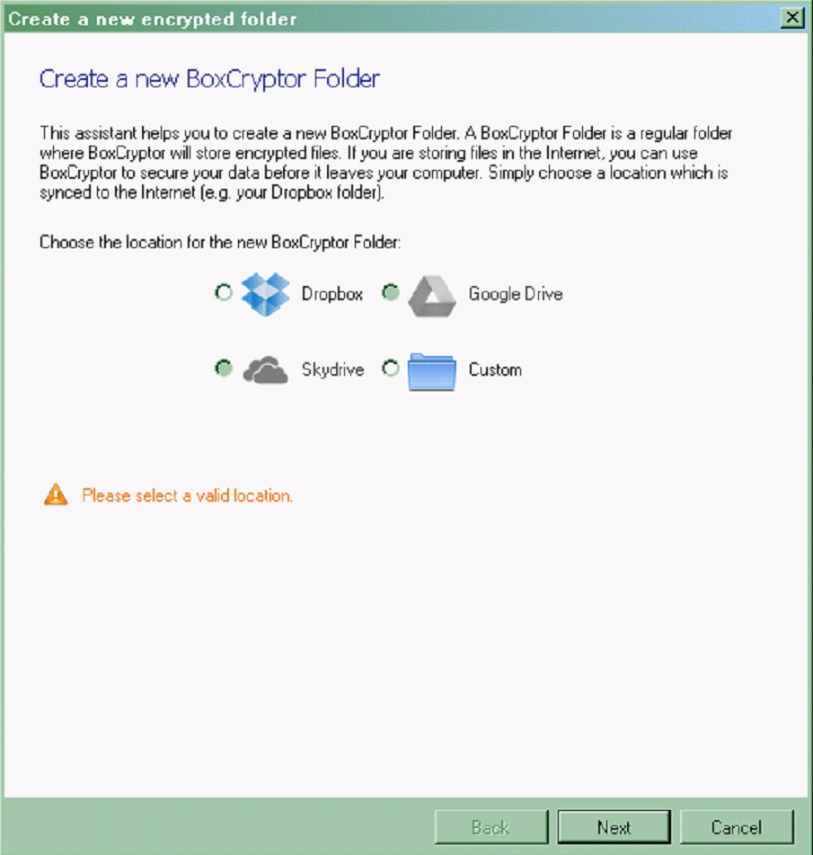

3) Check the radio button for the cloud service you intend to use. This will decide the local folder the BoxCryptor folder will be placed in.

Click the next button

The Screen will redisplay with the path of the folder. This will be in your local ‘my documents folder ‘ in the relevant subfolder for the cloud service requested.
Note if you specified custom, you can specify any folder you like. In this way you can have several BoxCryptor folders each with its own password.

You will also have a new field to enter the name of the folder you are going to create. By default this will be BoxCryptor, but again you can change this to anything you like

Click the next button
The following screen will display
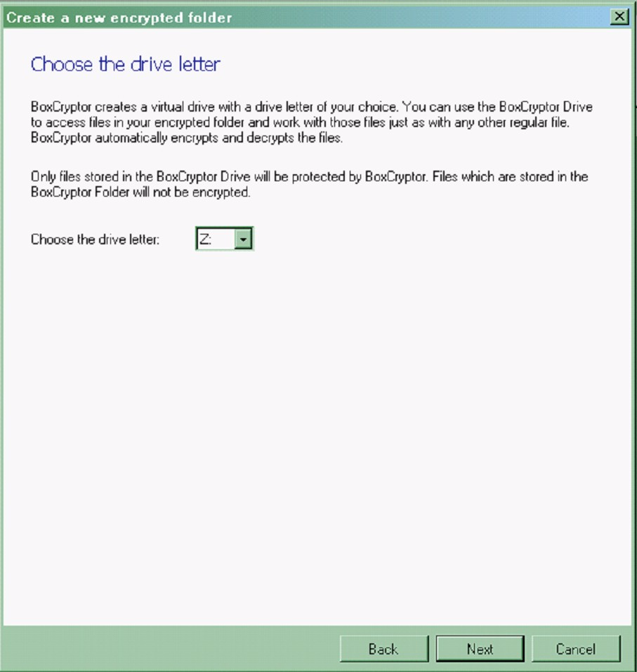

4) You are being asked what drive you wish to load this folder as to give you direct access to the files. The system will start at drive Z and take the next available free drive letter by default.

Click the next button
The following screen will display

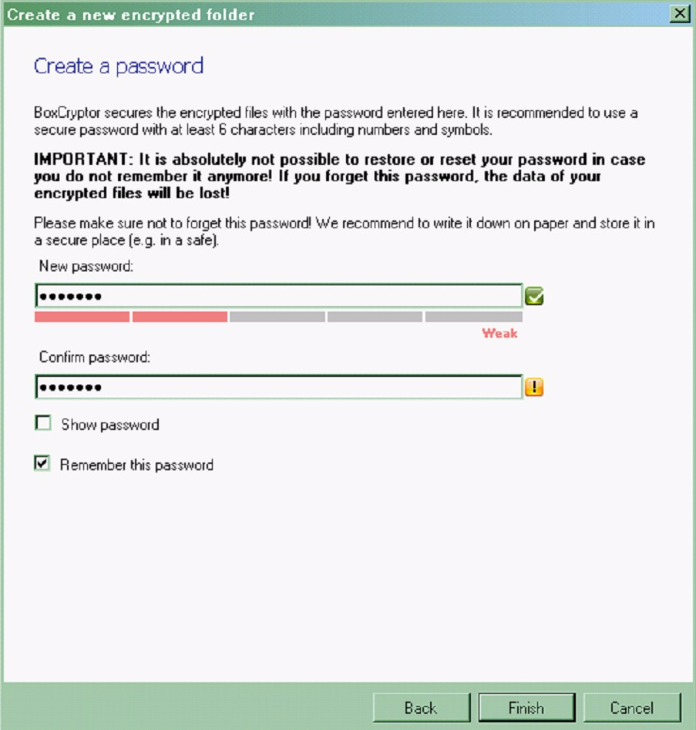

5) You are now being asked for the password which will be required to load this folder as a drive. Note that this folder is unrecoverable if you forget the password.

Enter the password of your choice and click the finish button.
The following screen will appear.

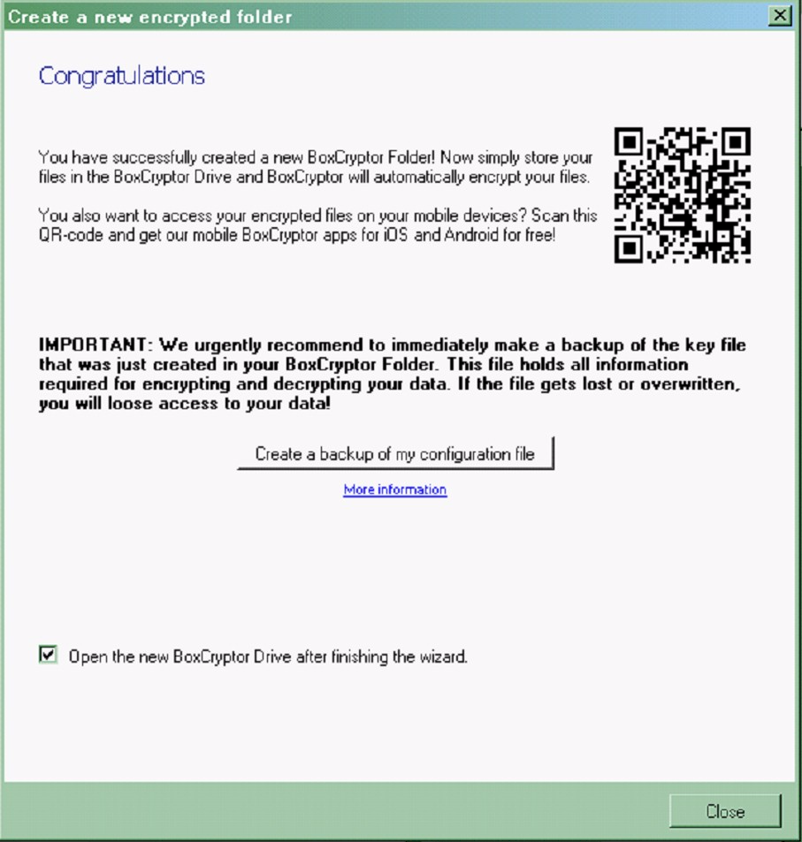

6) Follow the instructions of the screen if you wish to access your files through a mobile phone.

The screen is asking if you wish to make a backup of the key file. BoxCryptor will use the password you supply and the keyfile together to encrypt any data you are going to put in this folder. By default the keyfile is created within the BoxCryptor directory. It needs to be here so that the receiving person can just enter the password to access the folder and decrypt its contents. However, anyone accessing this folder in unencrypted mode, i.e. just opening the folder without access through a drive letter will see the files even though they ant read them. This also means they can delete any file within the folder, including the keyfile itself, so the system is now asking if you wish to backup this keyfile so you can restore it in case of deletion. It’s always a good idea to create a backup.

Click on the backup button and a screen is displayed asking you for a name and location of the backup file.
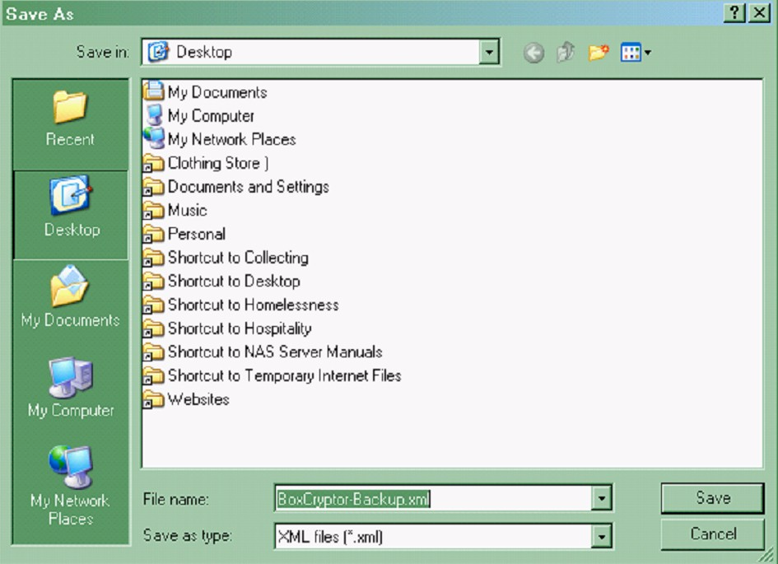

7) Once you have saved the backup, explorer will open the drive letter you have requested to load your folder as. Several PDF files will already have been placed there to explain its use. If you change your explorer view to show hidden and system files you will see some other files as well. Do not delete. Leave these in the folder.

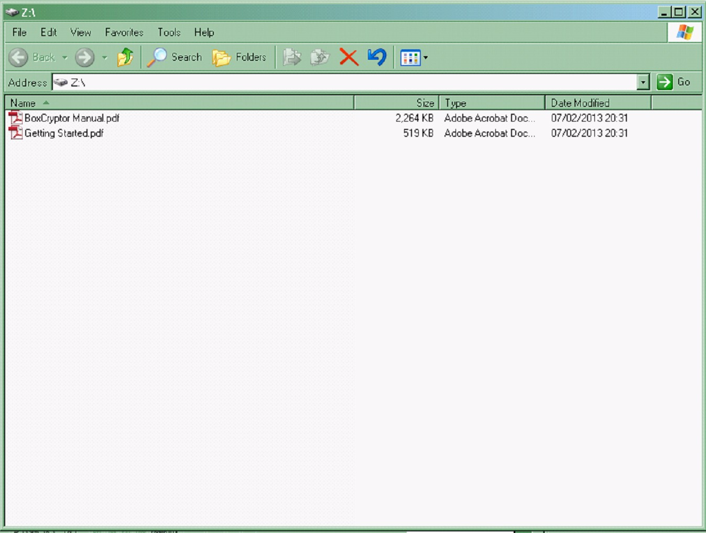

When you look at this folder through the drive letter (in this case Z) you can open the files without problem even though they are encrypted. For example opening one of the PDF files will open adobe and allow you to read the document. If on the other hand you open the actual folder, e.g. my documents/dropbox/BoxCryptor.bc, you will see the same files but will not be able to open them. You will receive a message saying the file is damaged because it is encrypted.

If you add any files to my documents/dropbox/BoxCryptor.bc they will be unencrypted. If you add any files to the Z drive, they will be encrypted. SO always use the Z drive to place files in this directory. You can open the directory b y right clicking on the BoxCryptor icon in the quick start area of the screen and selecting ‘open’.

If you drag and drop any file to the Z drive, it will be encrypted when it is placed here. Similarly, if you drag and drop and file from this drive, say for example to the desktop, it will be unencrypted.

If you have more than one encrypted folder, to unload one and load another, just Right click on the BoxCryptor icon and select ‘Preferences’ and when the main screen appears click on the advanced button. The following screen will appear

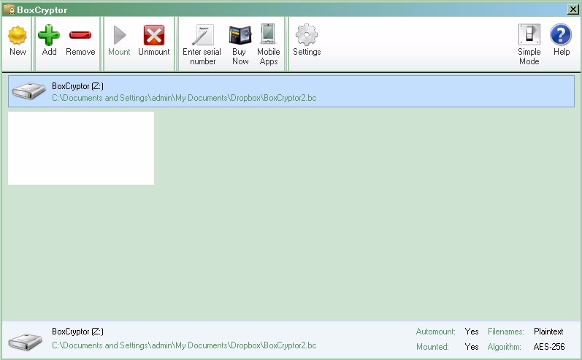

Highlight the folder that’s mounted, in this case Z and click the unmount icon at the top of the screen. You can then click on the Mount icon, to mount an alternative folder you may have or the new icon to create yet another encrypted folder and mount is. Again remember they don’t have to all be in the Dropbox folder, they can be anywhere. Also note that you can have as many encrypted folders as you want in a single physical folder, so for example you could have a Dropbox folder holding three or four encrypted Dropbox folders, all with different names and passwords. In this way you can limit access to certain files to certain users you share your Dropbox with.

