Encrypting a file with 7-Zip

To transmit an encrypted file attachment one of the easiest ways to do this is to create an encrypted file using 7-zip. Download and install the program from http://www.7-zip.org/

1) Start the program. The following screen will appear

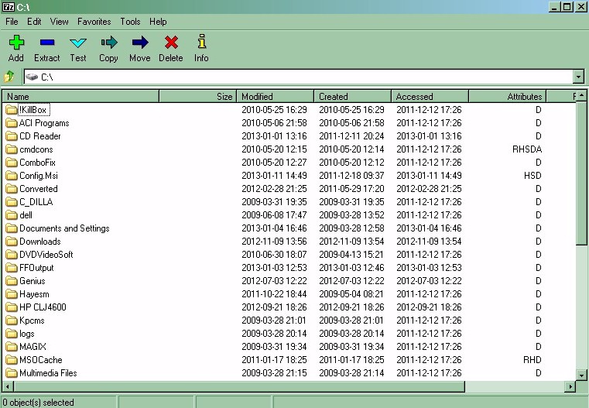

2) Locate to the directory containing the files you wish to transmit. Then click within directory you want all the files you want to add and click on the add button
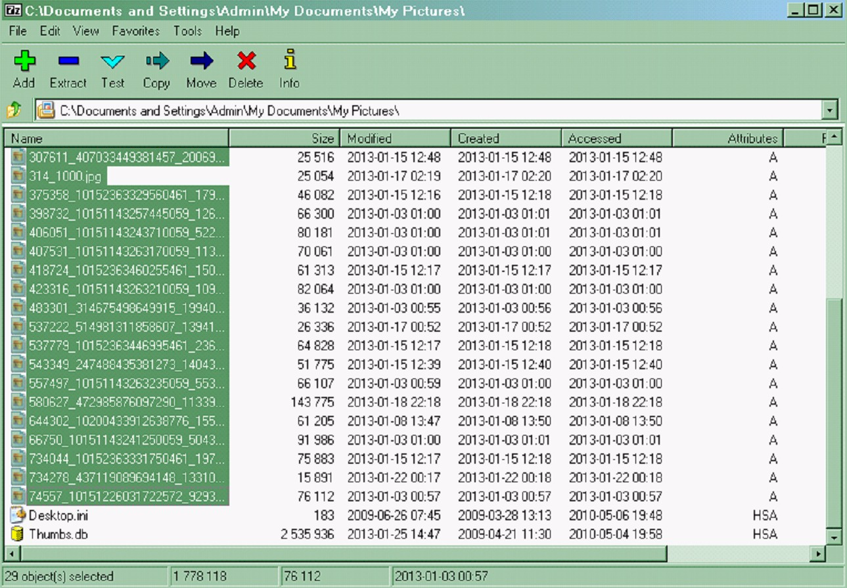

3) The following screen will now be displayed. Enter the name of the file you want to create. By default the archive format is 7z. If the person you are sending the file to doesn’t have 7zip installed you can change the default to ZIP. He will still be asked for a password when he attempts to unzip it, however he will see the names of the files in the archive so it’s more secure to leave it as it is and send a link to download the 7-zip program as part of your email. Also note that if you use a standard ZIP file then the default encryption method will be different/. You need to change this back to AES-256 to get the most secure from of encryption.

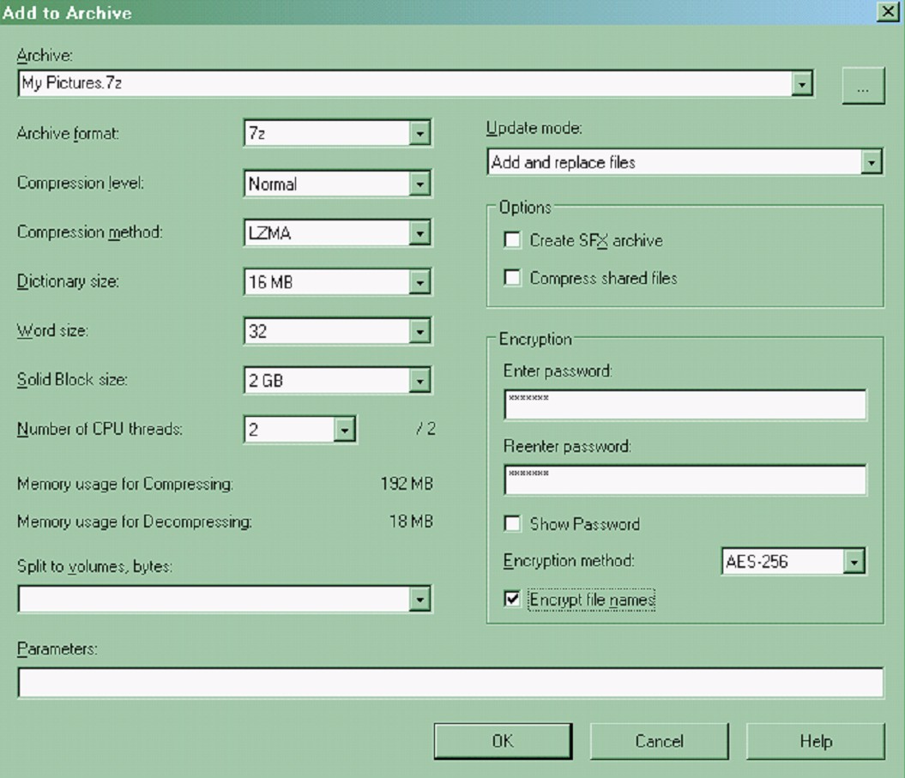

Enter a password for this file, and check the box ‘encrypt file_names’.
Click ok

4) The following screen will be displayed and the encrypted zip file created.

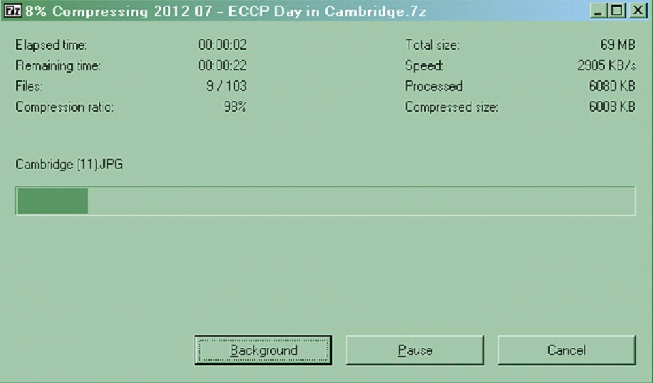

5) The resultant file can now be attached to an email and transmitted securely.

6) When received, when the recipient saves this file to disk and tries to access it he will receive the following message

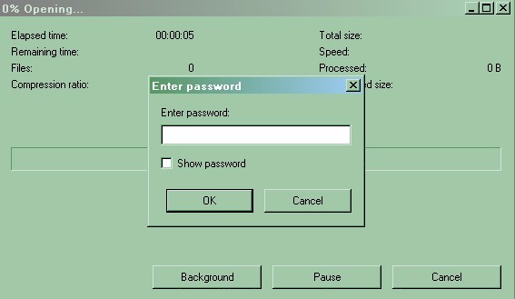

He will get no further until he enters the correct password. Once the file is opened successfully either the extract icon can be used to restore the correct file or the recipient can just drag and drop onto the desktop or another folder. Copying a file out of the encrypted file automatically decrypts that file.

