‘Cloud’ sharing encrypted files securely using TrueCrypt

Dropbox and other social networking sharing services, like Google drive, Microsoft SkyDrive and others, promise safekeeping of your documents, and the use of encryption methods, but the recent security breach as highlighted by the BBC shows the dangers of using such sites at present. NEVER store a confidential file directly to this type of drive. If you have to store any information in the cloud for portability, then encrypt the files first on your machine using TrueCrypt then store that encrypted container inside your Dropbox, Google drive or other online storage space.
If you are intending to access these files through an iphone or an android phone then use BoxCryptor instead, as this already provides the relevant apps to unlock the encryption.
If you are intending to share these files with more than one user, then Use either BoxCryptor or 7-Zip instead

1) Following the Truecrypt Setup instructions, create the encrypted container in the local Dropbox folder, within your local ‘My documents’ folder. In the following example we have called this container ‘encry folder’.
.
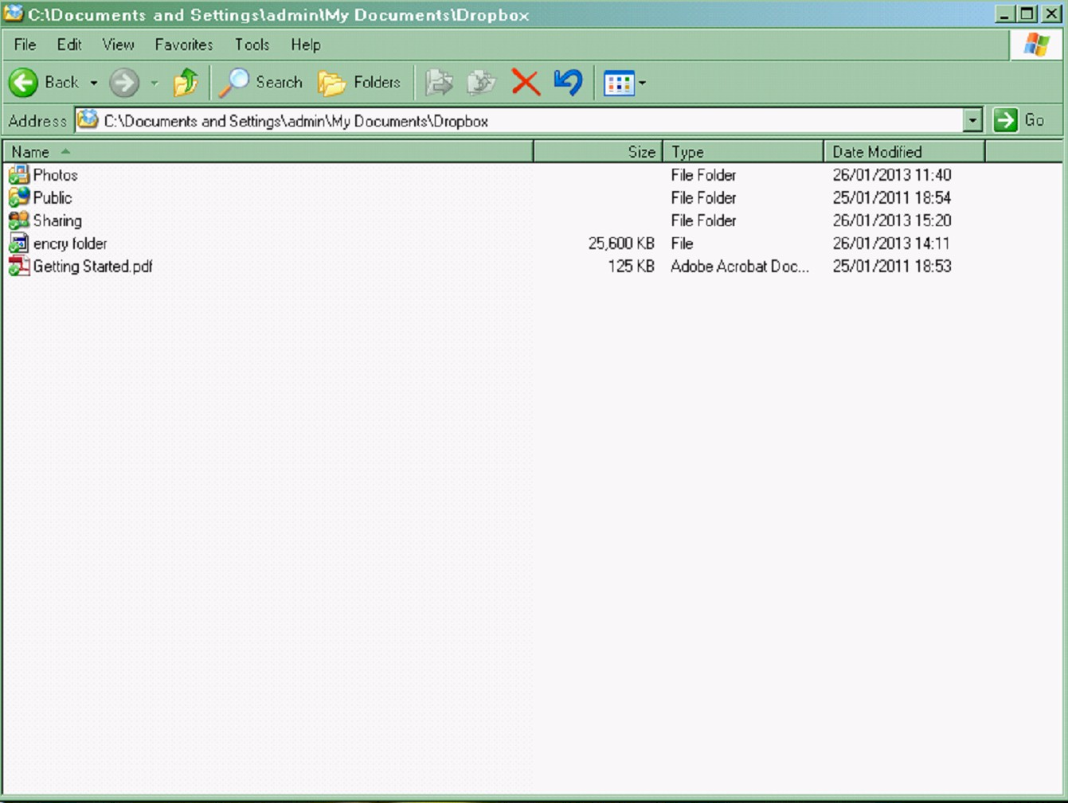

2) The container, in this case called ‘encry folder’, will be attached to you through Truecrypt as one of your drives. Just copy over the files to the relevant drive that you wish to share with someone.

Within Truecrypt you will then need to unload the drive the file is connected as, to remove the file lock to allow synchronisation.

The Dropbox upload icon on the bottom right of your windows screen should show that Dropbox is uploading the encrypted file.

Logon to your Dropbox user. The following screen will be displayed

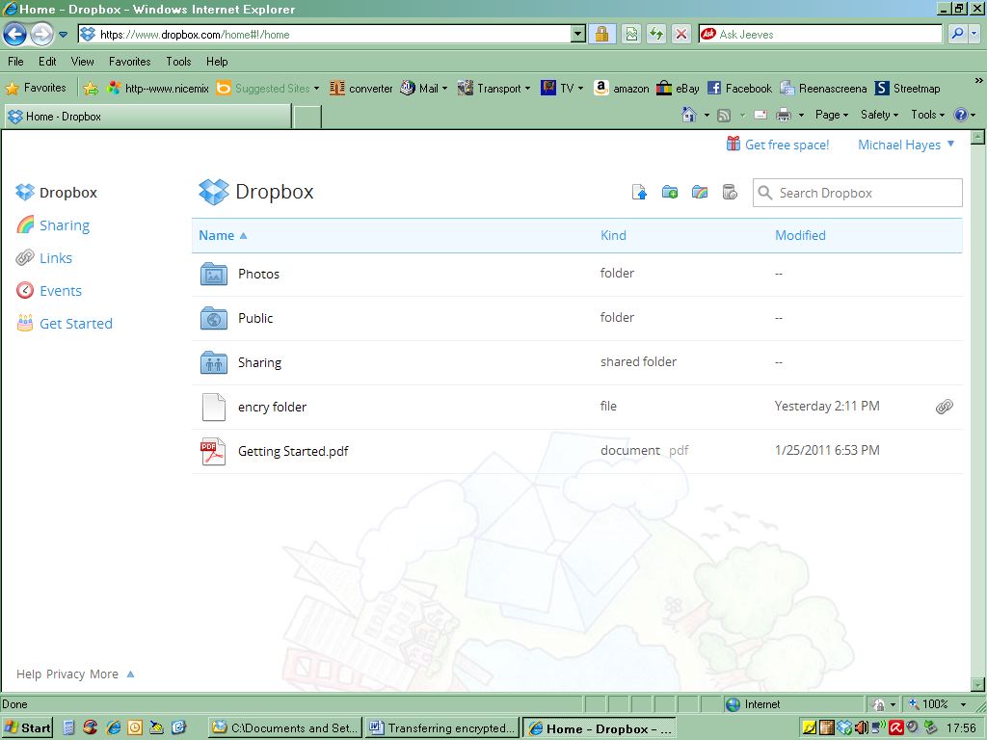

3) Right click on the encrypted folder you wish to share.
On the dropdown menu select ‘Share link’
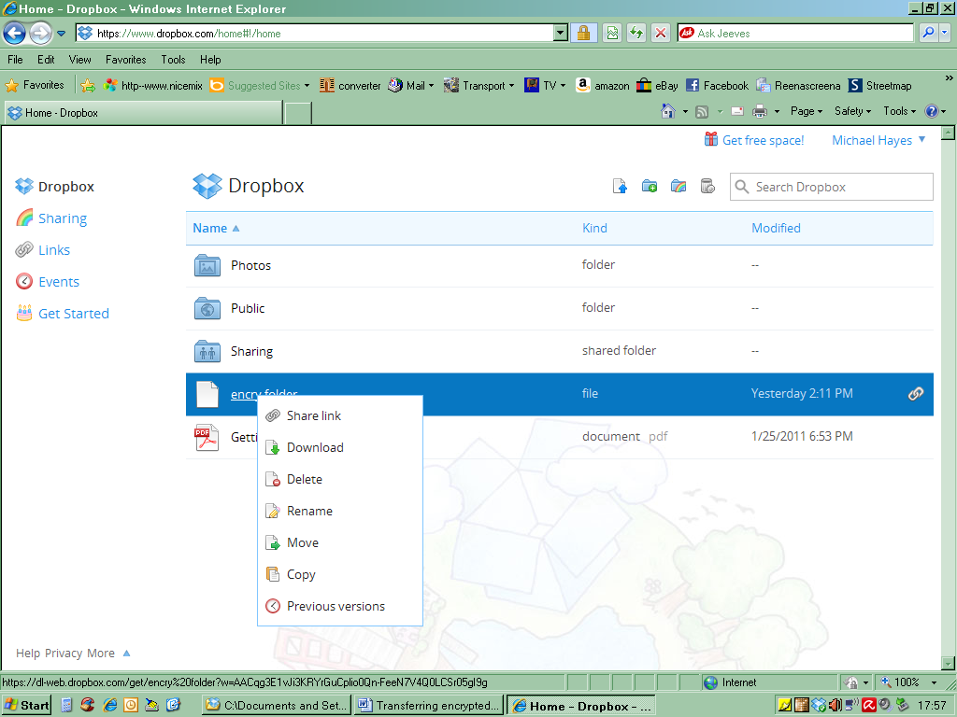

4) The following popup box will appear. Enter the email address for the person you wish to share this file with.

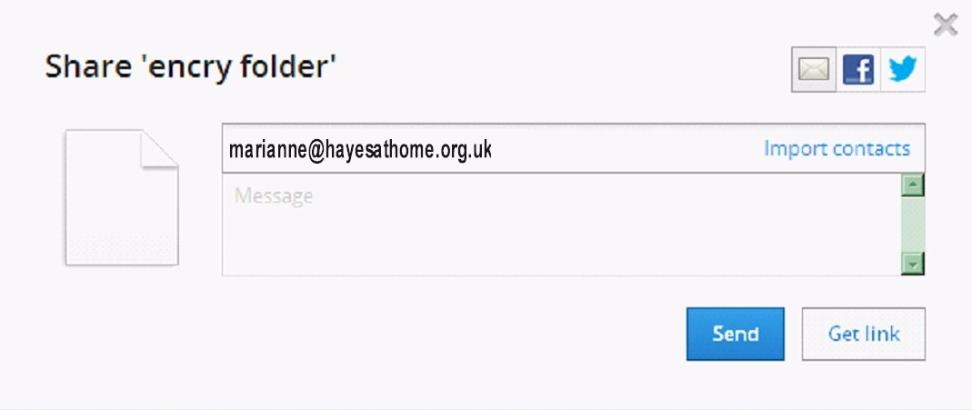

5) When the following prompt appears, click done
The user you have invited will now receive an email and when they click on the enclosed link they will be verified and in their Dropbox will see the shared file.

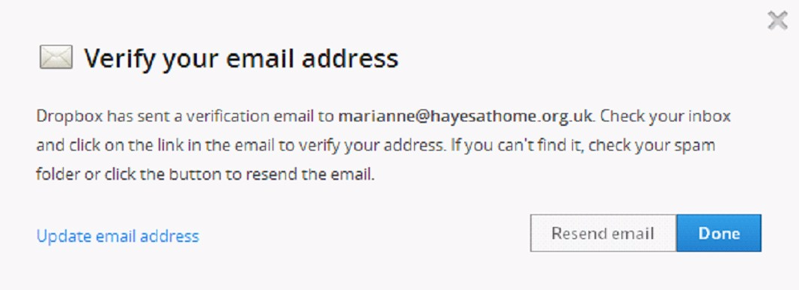

Very Important!!! - (Restrictions on Truecrypt)

There is a problem with sharing an encrypted container file created by Truecrypt. When the shared file is synchronised to the other users machine, and they then make amendments, the amended file will be reloaded to Dropbox and synchronised back down to your machine. Great in theory, but what happens when you have many users all sharing. Because the container is seen as a single file, updates could be lost by a person not having the latest file on their machine because the current one is locked. If they then make amendments to what they believe to be the latest copy, and their file’s date and time signature is later than the one online, their file becomes the master and is therefore uploaded, maybe using some internal files you or another user may have placed there whilst you have been working on the files.

Additionally, the whole container needs to be uploaded, equating to all the files within the container. If this is a large container, then the overheads can cause more headaches.

For this reason this method of sharing encrypted data should not be used.

Use Either BoxCryptor, or create a shared folder within Dropbox and invite as many users as you wish to become part of the shared folder, then use 7-zip to encrypt the relevant files. .

