‘Cloud’ sharing encrypted files using 7-Zip

1) Create a folder you intend to use as the shared folder in the local Dropbox folder, within your local ‘My documents’ folder. In the following example we have called this container ‘sharing’.

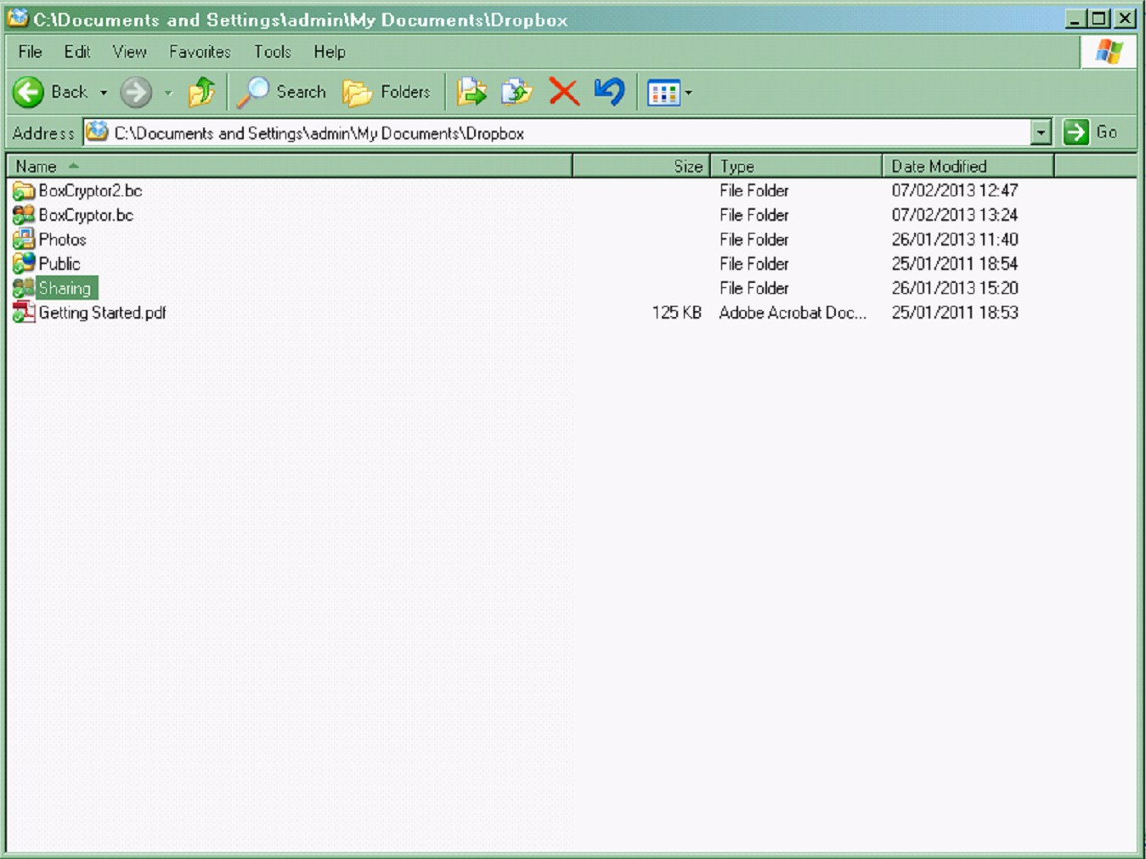

2) The Dropbox upload icon on the bottom right of your windows screen should show that Dropbox is uploading and creating the Shared folder.

Logon to your Dropbox user. The following screen will be displayed

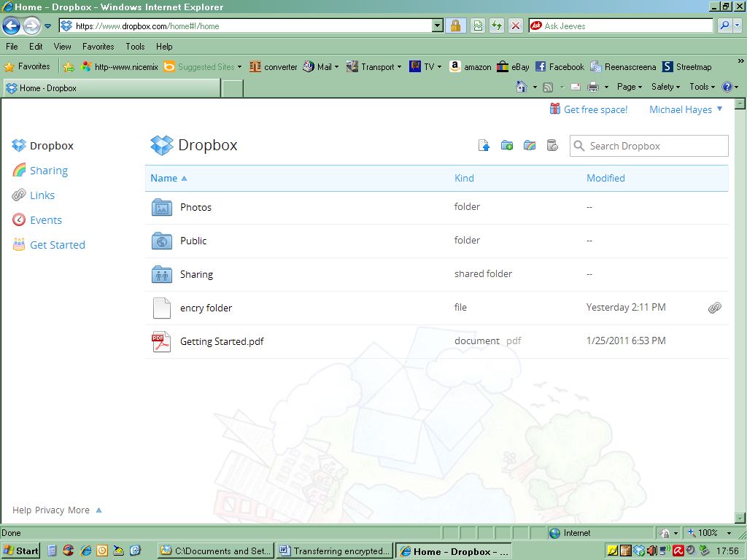

3) Right click on the ‘sharing’ folder you wish to share.
On the dropdown menu select ‘Share link’

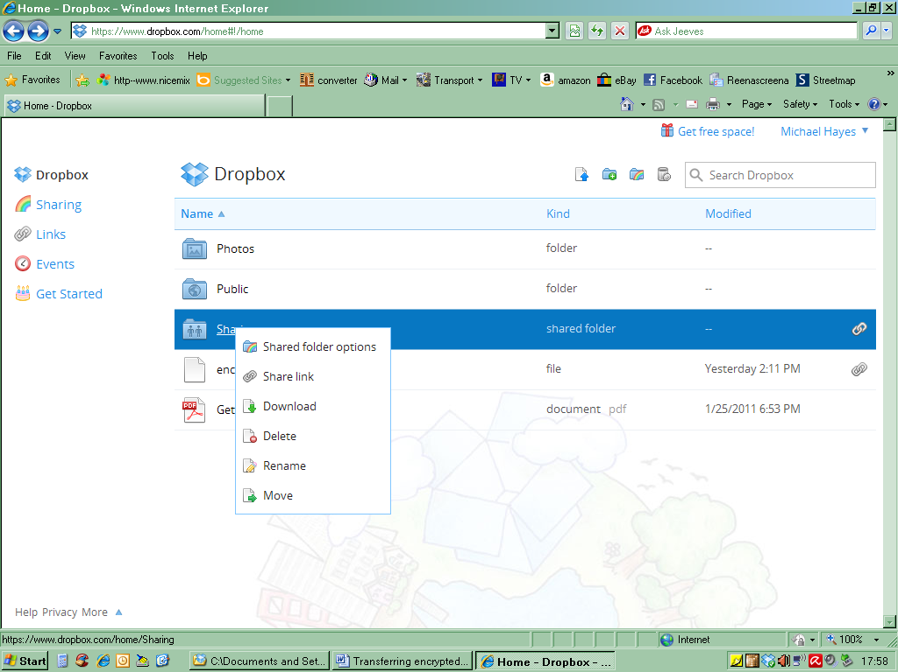

4) Right click on the ‘sharing’ folder you wish to share.
On the dropdown menu select ‘Share link’
The following screen will be displayed

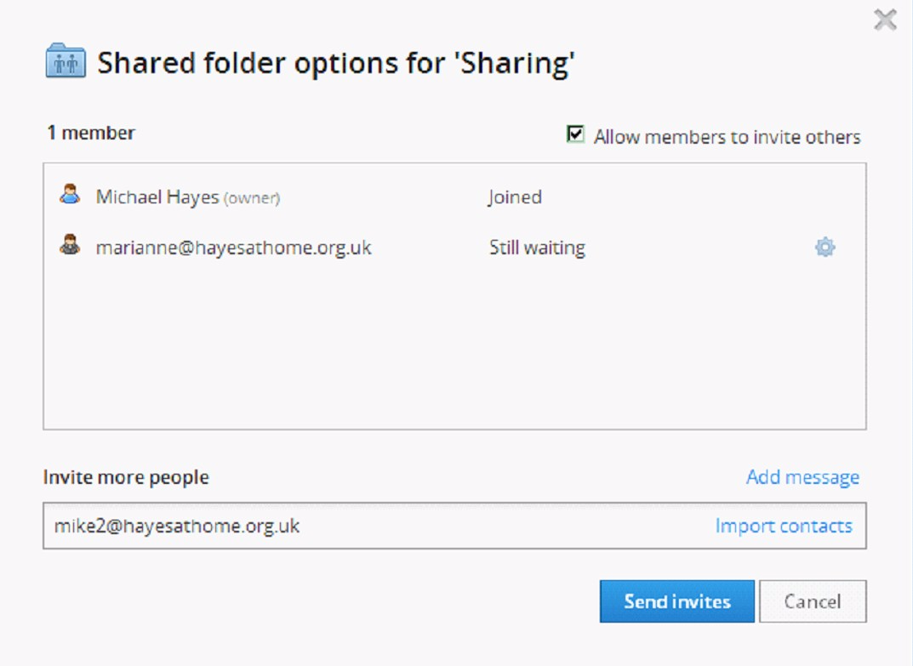

5) You can invite as many people as you like to share this folder with you. For each you can additionally specify that they can invite other people to share as well. For each person you invite by email a popup box will display telling you they have been sent an email, which they need to open and click on the link sent to them to verify them as a valid user.

From now on when they logon to their Dropbox user, they can see the same folder as you, as shown in the following example.

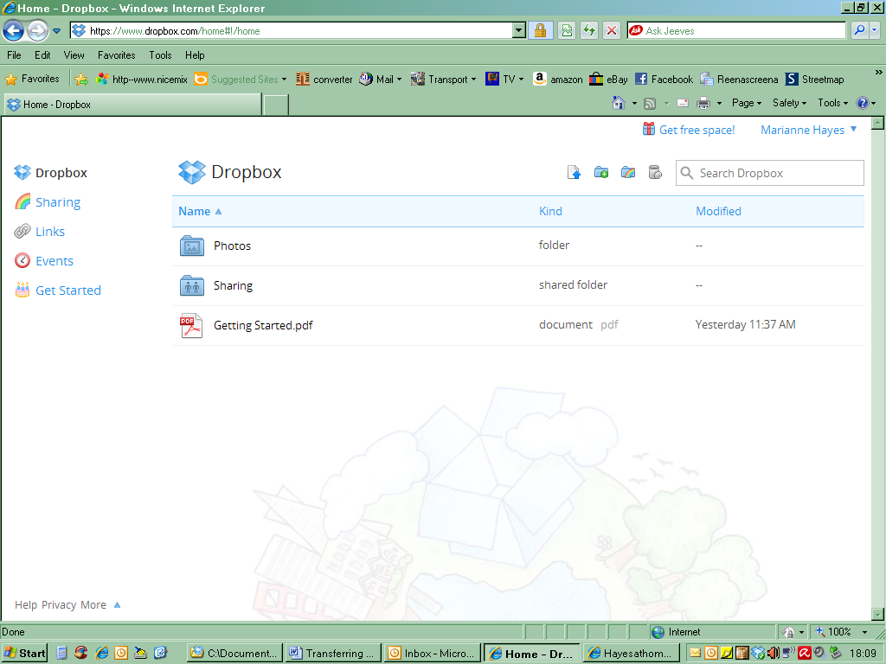

6) Place in this folder files created using 7-ZIP. Make sure you send the password to unzip the encrypted zip file securely.

